

DTI Template 304

Test Strategy & Plan

Project name & ID

Document Author: Insert name

Date Created: Insert date

Template Data

|  |  |  |  |
| --- | --- | --- | --- |
| Title | Test Strategy & Plan | | |
| Description | DTI level test strategy used for all projects and BAU.  Exclusions: Large programs where a separate strategy is created and approved | | |
| Template ID | DTIPMO304 | Classification | Internal Use Only |
| Template Owner | Mohit Pande  Senior Manager – Testing | Template Approver | Grant Wolfaardt  Head of Technology and Architecture, IT –Infrastructure Operations |

Template Revision History

|  |  |  |
| --- | --- | --- |
| Date | Author | Revision |
| 15th October | DTI PMO | Draft Template Rebrand & Naming convention |
|  |  |  |
|  |  |  |
|  |  |  |
|  |  |  |
|  |  |  |

*Attach to Business Case Request for Approval.*

**Approvals**

This document requires following approvals. Signed approval forms are filed in the Quality section of the PCB.

|  |  |
| --- | --- |
| Name | Title |
| Grant Wolfaardt | Head of Technology and Architecture, IT –Infrastructure Operations |

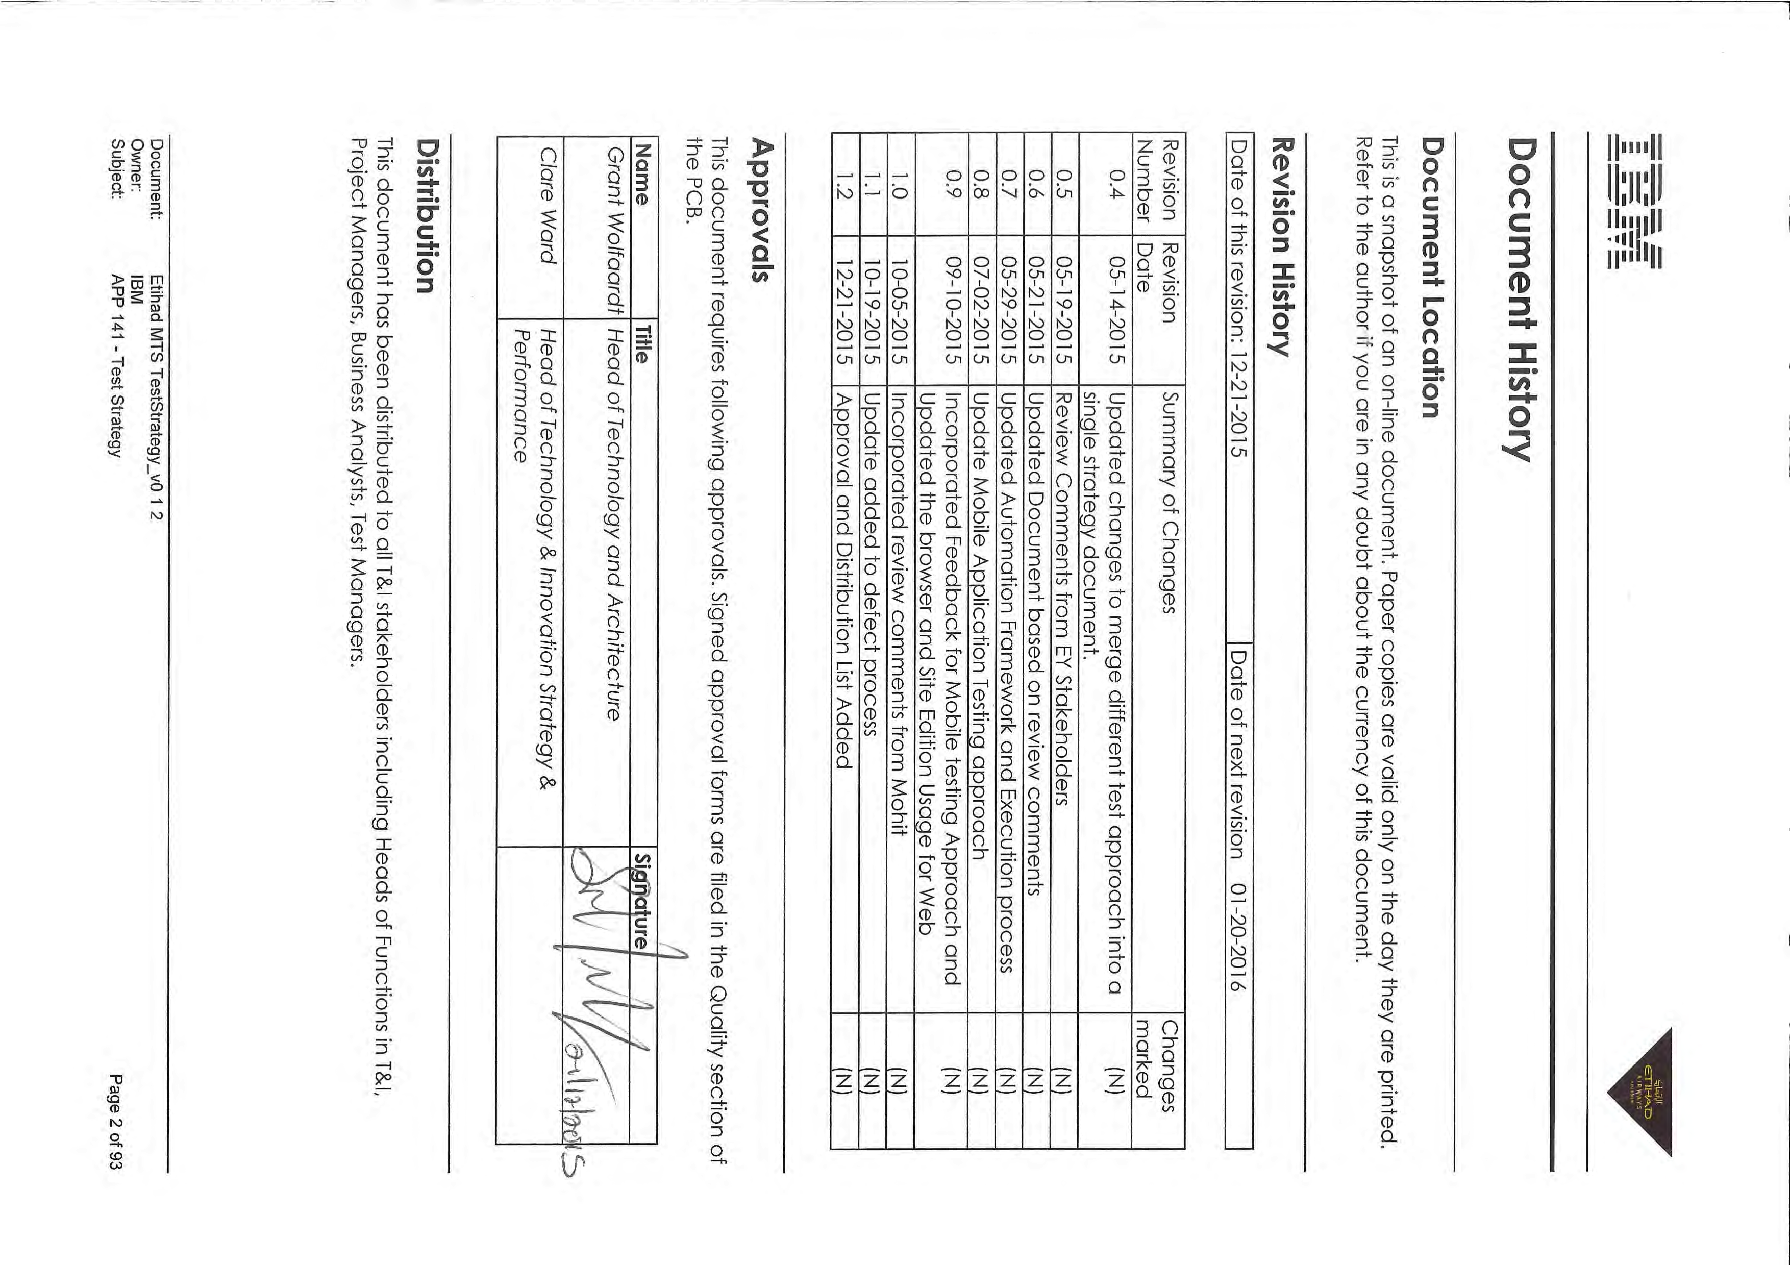

**Contents**

Introduction 6

Scope 6

Assumptions 6

**Requirements:** 6

**Test Cases Complexity** 6

**Test Environments** 7

**Test Data** 7

**Business/ Technology and Innovation Support** 7

Testing Objectives 7

Risk Assessment 8

Levels of Test 9

**Requirements Analysis** 9

**System Testing** 9

**Systems Integration Testing** 9

**User Acceptance Testing Support** 9

Types of Test 9

**Functional Testing** 9

**Web Based Testing** 10

**ETL/DWH Testing** 13

**Interface Testing** 15

**Customer Validation Testing** 15

**Product Testing** 16

**Mobile App Testing** 17

**Production Fixes and Small Changes** 20

**Non Functional (Performance) Testing** 20

**Introduction** 20

**Key Areas of Performance Testing** 21

**Performance Analysis/Tuning Runs:** 27

**Maintaining test run logs:** 27

**Performance analysis and tuning:** 28

**Documenting final performance reports:** 28

**Automation Testing** 29

**Approach:** 30

**Proposed Solution for Test Automation** 30

**Execution Process to be followed to run the Test cases** 32

**Creation of new scripts in RFT using Etihad framework** 38

**Quantitative Benefits of this Framework** 46

**Qualitative Benefits of this Framework** 47

**Assumptions, Constraints and Dependencies** 47

Test Process 48

**Waterfall Model** 48

**Agile Model** 48

Entry / Exit Criteria 49

Tools 51

Metrics 51

Test Management and Reporting 52

**Defect Management** 53

**Defect Workflow and States** 54

**Defect Severity & Priority Definitions** 55

**Defect Turnaround to be followed based on Defect Severity** 56

**Defect Triaging/Review Meeting** 56

**Assigning Defect to Vendor Supplier** 57

**Defect Validation Process** 57

**Defect Reporting** 58

**Defect Logging In RTC** 58

**Test Completion** 63

**Change Management Procedures** 63

Approvals 64

Appendix A – Glossary of Testing Terms 64

**Introduction**

This document aims at laying down the Test Strategy that will be followed for Etihad Managed Test Service. Going forward this document shall be referred by the Etihad MTS team to guide them on the Test Approach they will be following for various types of testing under scope for Etihad MTS. Test effort will be prioritized and executed based on the project priorities as defined in the Project Plan, Test Plan and Requirements Specification. This is a living document that may be refined as the project progresses. The Test Managers, Test Team Leads, Offshore and Onshore Delivery Leads and Project Managers will review and approve the final version of the Test Strategy document.

**Scope**

The scope of Testing for Etihad Managed Test Service during steady state of delivery will be limited to the following:

1. Functional Testing
2. System Integration Testing
3. Regression Testing
4. Non Functional Test
5. User Acceptance Testing Support

**Assumptions**

Following are the assumptions that will drive the testing performed for Etihad:

**Requirements:**

Requirements to be provided are considered complete and testable, and are available in English language otherwise Etihad BA/Development teams will assume the translation cost; also, application development functional and technical documentation provided to IBM.

Testing cycles will heavily depend on accurate representation of original business functional and technical non-functional requirements, associated design documentation and understanding of operational and runtime requirements. If these are not complete or undergoing changes, or adequate/ accurate information is not available, then this may impact the quality of Testing performed by MTS.

**Test Cases Complexity**

Test case complexity is defined / assumed as:

High Complexity: 16 to 25 test steps,

Medium Complexity: 10 to 15 test steps

Low Complexity: Less than 10 test steps.

**Test Environments**

MTS will have all requisite access to systems and data in the Etihad test environments, for provision of services from Onshore & Offshore;

The requisite Rational and other Test tools that MTS and Project team agrees to provision as part of Test Plan are installed on the Etihad test environments and will be available to MTS for use through-out the duration of testing.

MTS will be performing a smoke test on the Application deployed for Testing before starting with the actual Test Execution Cycle.

MTS will be performing Functional Test (System, SIT, Regression) on Etihad TEST environment followed by PPE environment if required (as specified by the project and documented in the Test Plan) in line with Technology and Innovation PMO processes.

NFT tests would be performed on PPE Environment.

Any exception for skipping verification in TEST environment would need approved dispensation.

No testing will be performed in Etihad PROD environment. Only exception to this would be smoke test on public sites which do not expose any PI/SPI to MTS

**Test Data**

MTS would include Test Data requirements as part of Test Plan / Test Approach for the specific project. These Test Data requirements would be agreed along with timelines for Test Data Provisioning. Any delays on these agreed milestones are expected to have cascading effect on the Test execution timelines.

MTS will not be involved in extraction, transformation and loading of test data into the test environments from production environment or other sources.

**Business/ Technology and Innovation Support**

Availability of Etihad’s business and Technology and Innovation teams, as well as technical teams/ vendors for each of the Consumer/ provider applications, is critical for completion of the Testing activities for Test Team. Key areas where support is needed include

* Requirement Validation and conflict resolution
* Test Environment Build / Support
* Test Data Provisioning
* Participation in Defect Triage and Defect Resolver group resource commitment.
* Configuration and Change Management on Test Environment.

**Testing Objectives**

Testing is the systematic search for defects in all project deliverables. It is the process of examining an output of a process under consideration, comparing the results against a set of pre-determined expectations, and dealing with the variances.

Testing is conducted to ensure that a product developed will prove useful to the end user.

Primary objectives of testing will assure that:

* System meets the users' needs ... has 'the right system been built'
* User requirements are built as specified ... has 'the system been built right'
* Describe system behavior (i.e. ensuring that we effectively understand how the system behaves under test conditions)
* Discover defects as early as possible (i.e. find defects in requirements, design documents, code as early as possible in SDLC)
* Confirming Etihad’s application performance is in line with Business expectations and industry standards.
* Ensure that the project requirements are traceable, testable and prioritized based on vigorous risk assessment of business, testing and environment requirements.
* Improve the effectiveness of testing of projects and business as usual activities by reducing the efforts to find more defects.
* Increase defect fix rate by improving defect feedback.
* Verifying that the systems are recoverable in the event of failure, such as server failure
* Verifying that the applications satisfy the acceptance criteria specified by the business \ Technology and Innovation OPS
* Verifying that the systems adequately support in scope and end to end business processes
* Promote reusability & minimize duplicated testing effort by reusing established testing artefacts (test cases & scripts) & where possible automating the test effort
* Validating that system deliverables are fit for purpose
* Reach a target state of test automation as code moves from the various environments following “Route to Live Process” with minimal manual intervention

Primary Guiding Principles for testing will be:

* Plan Early – Test Involvements from the Business Case phase
* Save Costs with Phase Containment –Early defect detection in the SDLC
* Test Important Things First – Priorities test cases based on Business importance
* Report Progress Regularly – Daily Test Execution Reporting
* Manage by Metrics – Test Progress %, Defect Detection Rate, Defect Density across products captured.
* Retain Test Documentation- RTC/RQM single source of all Test Artifacts.
* User Acceptance Tests – Support

**Risk Assessment**

Risk assessment will be driven by the business functions and technical requirements of the solution under test .Risk identification and mitigation actions for areas requiring additional focus will be documented in the individual Test Plan for the project

**Levels of Test**

The system will be tested in line with the build and release strategies, from individual projects through integrated subsystems to the deployed releases and to the final system.

Testing will proceed through various physical levels of the application development lifecycle. Each completed level will represent a milestone on the project plan and each stage will represents a known level of physical integration and quality. These stages of integration will be known as Testing Levels.

The Levels of Testing used in the application development lifecycle are:

**Requirements Analysis**

Requirements Analysis will involve the verification and validation of requirements through static tests. The validation testing of requirements will result in logging issues and discrepancies and incompleteness of requirement back to appropriate Project Stakeholders (i.e. Business Analysts or Project Managers).

**System Testing**

System level tests will verify proper execution of the entire application components including interfaces to other applications. Both functional and structural types of tests will be performed to verify that the system is functionally and operationally sound.

**Systems Integration Testing**

Systems integration testing is a test level which will verify the integration of all applications, including interfaces internal and external to the organization, with their hardware, software and infrastructure components in a production-like environment.

**User Acceptance Testing Support**

User Acceptance tests will verify that the system meets user requirements as specified. It will simulate the user environment and emphasizes security, documentation and regression tests and will demonstrate that the system performs as expected to the sponsor and end-user so that they may accept the system. MTS will support user acceptance testing to the extent of assisting UAT Users with the Application flow, review of defects logged during UAT and validation of defect fixes before UAT Users retests them. UAT Team is expected to have an assigned UAT Manager or coordinator in line with required segregation of duties between MTS and UAT teams.

**Types of Test**

**Functional** **Testing**

This test strategy covers the high level overview for the functional Testing activities. Following activities would be performed in order for any Testing Activities apart from exceptions as listed in Section 7.1.7

* Detailed test plan for SIT will be produced during the test preparation phase for each release and would be sent for sign-off by the stakeholders.
* Detailed test cases will then be derived from the solution design/mapping document and uploaded into the test management tool RQM (Rational Quality Manager).
* Before test execution commences, a brief Environment Verification test phase will be carried out by SIT to ensure that the test environment has been built correctly and that it is fit for purpose.
* Detailed test cases will be written in RQM. The output of this test phase will then signed-off by the EY PM/Test Manager. Test execution will not be commencing until this sign-off will be there.

MTS would follow the following phases for Functional Testing Activities. Any variance to this approach is captured in subsequent sub sections.

**Requirements review:**

MTS will receive requirements for the releases (Release notes/ BRD’s/ FRS) from Business/ Sabre and requirements to be verified with the Business for any query arises. Test team would review and raise any known concerns on Requirements from a testability standpoint.

**Test Scenario design:**

MTS will design test scenarios based on the received release notes and other relevant documents such as “BRS”, “BRD” etc. and test scenarios will be sent to Business stakeholders for review and sign off.

**Test Case design:**

Test cases would be designed in RQM post review and signoff of Test Scenarios. Test Case will have Pre-requisites and Detailed Test Steps sections to perform the testing.

**Test Data preparation:**

Test data is important for any kind of test. It is expected that Test data will be prepared in the testing environment where build is to be deployed. For Sabre products Test Data will be prepared either in TSTS (pointing to Test) or in CERT (pointing to Pre-Prod) environments.

Sabre Refresh Dates need to be considered while creating test data.

**Test Execution:**

Test Execution will be performed in TEST Environment followed by PPE if needed. Any request to skip Test and performing testing in PPE needs to be based on approved dispensation.

**Regression:**

Existing Regression suite would be run in the last cycle of testing. On completion of the release, additional Test Cases from the current release will be identified to enhance the regression pack.

**Automation Testing:**

Regression Test Suite will be handed over to Automation Test Team for automating the test cases after feasibility check on the Application

**Web Based Testing**

Etihad has multiple web based applications which go through changes driven by need of new functions or production fixes. Majority of these changes are accessible over multiple browsers and multiple site editions. Currently there are more than 50+ Site editions and are accessed in 400+ Browser variants.

Below is trend for Browser Usage based on Etihad usage data as on Sep 2015

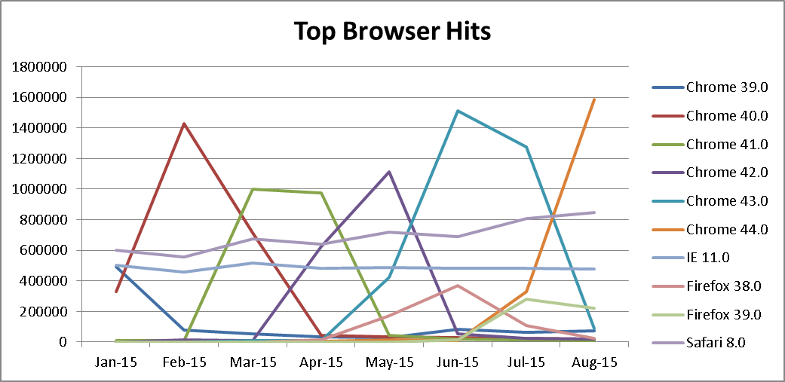

**Note**: - This data will change periodically based on browser usage and will be revalidated once we have the latest data and subsequently test strategy will be revised.

Additionally Site Edition usage is primarily on English sites with the following trend for past 9 months

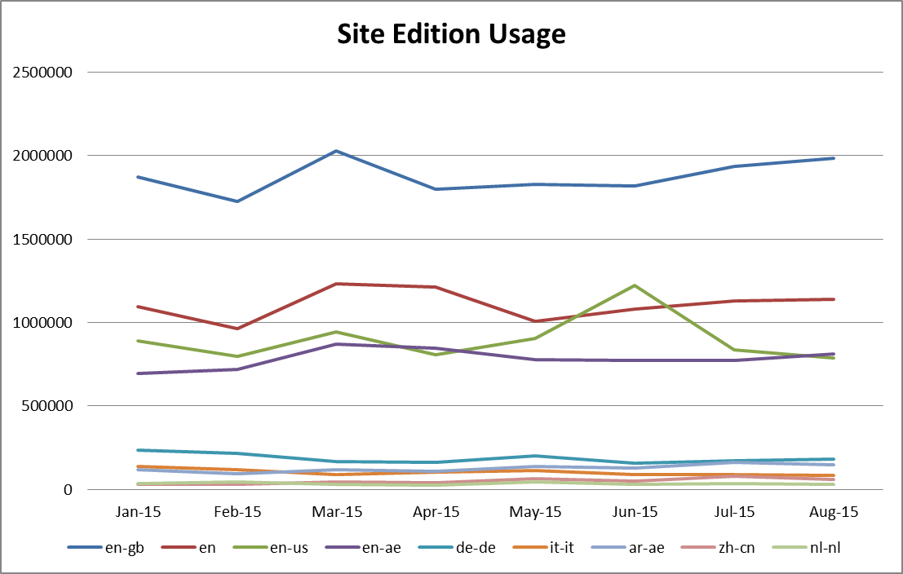

Considering the cost benefit analysis, timelines and impact of changes for a project it is not advisable to test all site editions in different browsers. Below is the risk based approach for testing these requirements considering usage of site editions and browsers. Below approach will ensure that a change or new functionality is representatively tested across browsers so that it is not broken and provides high degree of confidence that will be working fine for other.

Based on Usage MTS will prepare a Browser / Site edition matrix that will be considered for various testing scopes and documented below:

1. Based on current state during test planning maximum of 3 primary site editions i.e. en or en-gb or en-ar / ar-ae / de-de will be considered along with 2 secondary site editions based on specific impact will be considered (like it-it, zh-cn, nl—nl etc.)
2. Above mentioned site editions will be sampled across top 4 browsers. Browsers may be 2 versions down level for Chrome and Mozilla. For IE and Safari they can be 1 version down level. Available browsers in environment are listed below



1. 100% of test cases will be executed in first browser which is frequently used among above four (Chrome), 20% of overall test cases on second browser (IE) and 10% of overall test cases on third and fourth browser (Safari and Mozilla)
2. During test planning and execution it is to be ensured that a single site edition which is impacted primarily to be tested in one browser thoroughly and the remaining site editions are to be sampled across other browsers based on complexity of the test cases.
3. Test case identification for testing of second, third and fourth browser will be done in such a way that during execution it goes to multiple pages and is rated medium in Complexity.
4. Content Testing is not covered in SIT as content is dynamic and can be changed without any need of deployment. Testing Scope in this case would be limited to ensuring that application functionality has no impact for various types of content. This test would need active involvement of Configuration Support and Development teams to be able to change the content mapping files.
5. Language related tests will only be focused on proper presentation of the intended language in a variety of situations, for different users. Language related testing will not focus on correctness of language nor proper translations. Actual translation of the content will be out of scope for test team.
6. For requirements where changes are introduced specific to a site edition other than English, the functional aspect of the requirement will be tested and content accuracy of the language will be out of scope.
7. For new projects where site editions are introduced for the first time in such cases it is mandatory to test all site editions sampled across 4 browsers. If project timeline doesn’t allows performing exhaustive testing for site editions above approach to be followed with stakeholder approval.
8. For Website changes which impacts the mobile version of the application. Mobile Website testing would also be based on latest available Mobile Edition Usage and Revenue Statistics as made available by Business Users. Below approach would be used to test these mobile editions
   1. Sample Testing on Mobile Devices, where device is available
   2. Tests on Emulators if they are already Packaged in Etihad Environment or available in Etihad for use outside of Citrix.
   3. Remaining tests would be performed on Chrome Browser agents. These agents work for manual execution by adding plug in to the browser. Agent ensures that Chrome mimics the behavior of the browser testing needs to be conducted.

Detailed Approach on the same would be in Section 7.1.6.

**ETL/DWH Testing**

Etihad MTS ETL DWH testing project consists of the System Integration testing as part of the testing activities performed by Test team.

In SIT, the validation will be performed on the DWBI requirements. ETL/DWH Testing is the area where the validation of the business entities in terms of database attributes will be tested before the validation is performed for reporting.

| Test Phases | Description | Performed By | Environment | Deliverables |
| --- | --- | --- | --- | --- |
| System Integration Testing | * Systems Integration test phase for DWBI requirements and deliverables. Systems integration testing will be carried out first between the source and Staging and then from Staging to Data Mart through EDW. The purpose of this test phase will be to concur that the data movement from the source till the data mart happens as expected according to the Solution Design. In addition to this, as part of the E2E testing, data validation will be performed from EDW to DM and using BO as frontend. | SIT Team | * For Staging: Oracle, SQL Server 2008 * For EDW: SAP HANA, SQL Server 2008 * For Reporting: Business Objects (BO) | * SIT Test Plan * Test cases mapped to requirements & test results in Rational Quality Manager * Daily status update emails during test execution reporting progress & defects |

MTS team will agree and finalized scope of testing primarily focusing on below mentioned component within BI landscape:

1. Integration, Filtration and Transformation of data from Staging DB to EDW DB.
2. Storage of data in Data Marts from EDW
3. Validation of report data with the data present in data marts is in scope.

Areas that will be treated as out of scope for MTS team will be listed below and will have to be agreed with EY BI Business team that testing these will be done by business team and no help or MTS activity will be required:

1. Validation of data load in landing area.
2. Performing check and validation on migration of historic data.

The below figure depicts the high level scope of SIT.

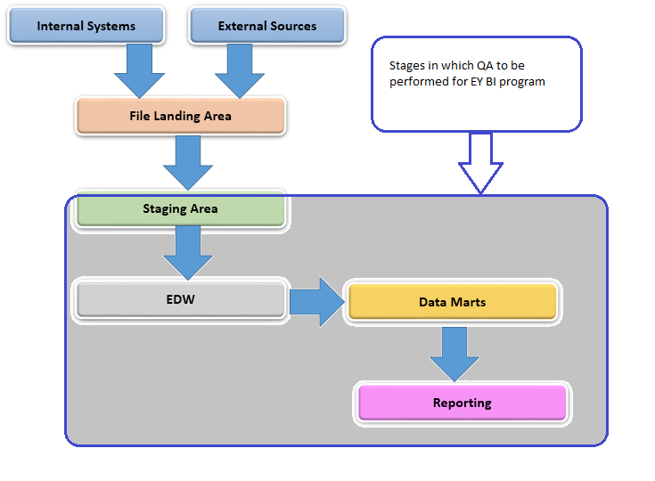

* DW-BI test activities will be conducted for all ETL releases as per requirements provided for the project(s).
* Each release and multiple drops within releases (if any) will be treated as a separate project for SIT in terms of test estimates, test plans and TCR.
* This test strategy covers the high level overview of the ETL/DWH testing.
* A detailed test plan for SIT will be produced during the test preparation phase for each release and would be sent for sign-off by the stakeholders.
* Detailed test cases will then be derived from the solution design/mapping document and uploaded into the test management tool RQM (Rational Quality Manager).
* Before test execution commences, a brief Environment Verification test phase will be carried out by SIT to ensure that the test environment has been built correctly and that it is fit for purpose.
* Detailed test cases will be written in RQM. The output of this test phase will then signed-off by the EY PM/Test Manager. Test execution will not be commencing until this sign-off will be there.
* Test execution will typically run in multiple cycles. First, the one-time Initial Load cycle will be run to validate that the initial load process works and the defect fix/regression will be tested in Cycle 2.
* The full scope of end to end testing will be included in the scope for SIT per releases.
* Tests are executed from RQM and will drive the daily reporting statistics and updates.
* Defect management will be performed using the RTC (Rational Team Concert)

**Interface Testing**

Etihad has distributed application landscape having many systems sharing information with each other in terms of data. This data can be exchanged using a formatted text specific to industry, through a file or by any standard data transfer messages like XML, EDIFACT etc.

Approach of interface testing will primarily focus on

* Checking of data categorization, transformation and consumption with respect to target system.
* Checking of error, failure and retry situations.
* Checking behavior and data availability in target system when relevant transaction is performed in source system.

**Requirements review:**

Early testing method will be followed were Test team will receive documents (IRS, ICD, mapping sheets) that will illustrate interface details, source & target system and all available technical specification that will be used as input to test design. Test team will raise series of queries and upon resolution all significant documents will updated and freeze.

**Test Scenario design:**

Test scenario will derived from inputs of documents which will go through series of internal review post which will be send to EY BA and technical teams to review and comments.

**Test Case design:**

Once the scenarios have been reviewed, test team will start the test case design in RQM. Pre-requisites and clear steps will be mentioned in the test cases. Multiple test cases will be designed for checking data categorization, transformation, consumption and failure cases based on mapping sheet and ICD.

**Test Data preparation:**

Test data plays very important role while performing Interface testing. Getting test data is predominantly Etihad responsibility, however test team will be providing test data request for setting up required data to be used while testing as a part of Test Plan

**Test Execution:**

Test Execution will be performed primarily in TEST Environment followed by Pre PROD Environment if needed. Any exception for direct execution in Pre-Prod would need a dispensation approval.

**Regression:**

Regression testing will performed in the last cycle of a release. Thereafter a regression suite will be prepared and constantly updated post every release to be run end of each release.

**Automation Testing:**

Regression Test Suite will be handed over to Automation Test Team for automating the test cases after feasibility check on the Application

**Customer Validation Testing**

Customer validation is about getting the product which people want. Customer Validation is about finding a repeatable scalable business model around that product.

The testing approach of the CVT (Customer Validation Testing) cover the following activities.

**Requirements review:**

Test team will receive the requirements of the releases (Release notes/ BRD’s/ FRS) from Business/ Sabre and requirements to be verified with the Business if any query arises.

**Test Scenario design:**

Test team will design the test scenarios based on the received release notes and other relevant documents such as “BRS”, “BRD” etc. and test scenarios are sent to Business stakeholders for review and sign off.

**Test Case design:**

Once the scenarios are reviewed and signed off by Business, test team will design test cases in RQM. Pre-requisites to be mentioned in the test cases.

**Test Data preparation:**

Test data is important for the system testing. Test data will be prepared in the testing environment where build is deployed. For Sabre products Test Data will be prepared either in TSTS (pointing to Test) or in CERT (pointing to Pre-Prod) environments.

Sabre Data refresh Dates will be taken into consideration while preparing for Test Data.

**Test Execution:**

Test Execution will be performed primarily in TEST Environment followed by Pre Prod Environment if needed. Any exception for direct execution in Pre-Prod would need a dispensation approval.

**Regression:**

Regression suite inherited for a Sabre product will be run during CVT. On completion of the release, additional Test Cases from the current release will be identified to enhance the regression pack.

**Product Testing**

Etihad Airways continuously work toward optimizing their resource utilization and providing best guest experience. As a part of this activity Etihad procure many OFF THE SHELVES industry standard product and these products are sometime tailored to meet Etihad customized requirements.

Methodology for testing a product will be no different from testing a customary software application; however alteration to the scope will be needed. Bullets below sketched the approach that needs to be followed while in each phase of testing:

**Requirements review:**

Early testing will be started were Test team will receive documents that will illustrate feature of the product and customized areas (could be user guide, Release notes, BRD’s or FRS) from Etihad Business team/ Project Managers. Test team will validate each of the provided documents to get a clear understanding of product and customized area.

**Test Scenario design:**

Test team will be designing the test scenarios based on the received release notes and other relevant documents such as “BRS”, “BRD”, “Product Features” etc. and test scenarios are sent to Business stakeholders for review and sign off.

**Test Case design:**

Once the scenarios will be reviewed and signed off by Business, test team will start the test case design in RQM. Pre-requisites and clear steps will be mentioned in the test cases.

**Test Data preparation:**

Test data is important for the system testing. Test data will be prepared as per the testing environment where build is deployed. For integration testing the data will need to be created in different system (like Oracle DB) and these data need to be verified in target system.

**Test Execution:**

Test Execution will be performed primarily in TEST Environment followed by Pre Prod Environment if needed. Any exception for direct execution in Pre-Prod would need a dispensation approval.

**Regression:**

Regression testing to be performed in the last cycle of a release. Thereafter a regression suite will be prepared and constantly updated post ever release to be run end of each release.

**Automation Testing:**

Regression Test Suite will be handed over to Automation Test Team for automating the test cases after feasibility check on the Application.

**Mobile App Testing**

Etihad has a number of applications for mobile devices primarily iPhones and iPads. There are two categories of apps: customer apps for Etihad’s end customer and enterprise apps for Etihad’s employees. The mobile app for iOS is still not released and active development happens in that area which requires the app to be tested continuously in the Agile mode. Apart for these there are around10 apps on iPads, which have, major and minor releases happening throughout the year.

|  |  |  |
| --- | --- | --- |
| **Etihad Apps** | **App Type** | **Targeted Users** |
| Etihad Mobile App | External | Etihad End Customers |
| Intelex | Internal | Employees |
| iPilot | Internal | Employees |
| mPilot | Internal | Employees |
| iKnow | Internal | Employees |
| FlySmart | Internal | Employees |
| Jeppesen | Internal | Employees |
| Boeing OPT | Internal | Employees |
| TMS | Internal | Employees |
| eHub | Internal | Employees |
| Works Home Apps | Internal | Employees |

All the testing for the iPhone apps as well as the iPad apps is done manually on physical devices currently.

The Etihad Mobile App as well as the Enterprise iPad Apps are iOS Native Apps. This means that these apps re built on iOS SDK using XCode IDE with the help of Objective C or Swift programming language. The installable files of these apps have .ipa extension.

Below are the considerations for the selection of the devices and the strategy around that:

* The Etihad Mobile App, which is designed for iPhones, is meant for the end customers of Etihad and is a public app. Therefore the device strategy needs to cover for all the users of this app. It has been traditionally observed that most users of iPhones are either on the latest iOS version or on the prior two iOS version, but not beyond that. Hence in terms of iOS versions, the latest iOS version at any point of time and the two versions prior to the latest version are in scope.

The iPhone hardware and the iOS are designed to be compatible with each other to the best of their capabilities. Also the latest iPhone hardware and the prior two iPhone models cover up for the largest user base of iPhone users. Therefore at any point of time, the latest iPhone model and the two models released prior to that are in scope.

The iPhone models and the iOS versions on them are continuously maintained to have the latest and the two prior iOS versions on them.

Whenever there is an OS release, the device with the oldest version of OS is upgraded to the newest one, so that the latest and two prior versions are maintained always.

* The Etihad Enterprise iPad Apps meant for Etihad Employees are also iOS Native apps that is, they are developed on iOS SDK using XCode IDE with the help of Objective C or Swift programming languages. Some of these apps like the iPilot app use widgets and public APIs like the weather widget etc. and those have a bearing on the iOS versions. Hence the iOS version is also a key consideration.

All the development on the Etihad Enterprise iPad Apps are carried out on the latest iOS SDK. The scope of testing in terms of OS version for these Enterprise iPad Apps is also latest public release of iOS.

Whenever there is an App upgrade for any of the Etihad Enterprise iPad Apps, the app is recommended to be tested in the iOS version, prior to the latest as well, order to cover the users of the app who are in the previous iOS version. This is a desired approach for the future.

Whenever a new OS version is released, a conformation is sought from the vendors of Etihad who develop the app, that the app has passed regression testing on the new OS version and that there is no dependency of the app on any of the APIs that have been deprecated in the new OS release.

Taking this confirmation as the basis, a regression testing is done by the test team. Based on the result of this testing, the Etihad employees are instructed to upgrade to the latest OS, thereby reducing the regression efforts.

When there is no active development or feature enhancement planned for the Etihad Enterprise iPad Apps but there is a new OS version forthcoming, the OS upgrade regression testing is done by the test team on the developer beta releases of the OS.

For the Etihad Enterprise iPad Apps there is a device maintained with the latest available developer beta version before the public release happens in order to do OS upgrade regression testing so as to get an early heads up if there are compatibility issues when the next OS version to be released. Similarly when the public release of the new OS version happens, the device on the beta version is upgraded to the latest OS version and a device with the latest and the prior version of the OS is maintained till the next OS version release is near. This cycle is repeated, every time a new OS version release is scheduled in the near future.

A previous version of OS is maintained in the iPads so that, in case of some ad-hoc defects being found, it can be crosschecked in the previous version as well. Thereby it can be concluded whether the OS up-gradation has caused the issue.

Following are the primary types of testing carried out:

* **Functional Testing:** Whenever there are new features released or any CRs implemented.
* **Regression Testing:** Whenever there are bug fixes in the release.
* **OS/App Upgrade Regression Testing:** Whenever there a new OS version release scheduled in the near future.

**Methodology followed for Mobile Testing**

Methodology for testing on mobile devices is no different from testing a customary software application; however alteration to the scope will be needed. Bullets below detail the approach which must be followed while in each phase of testing:

**Requirements review:**

Early testing will be started were Test team will receive documents that will illustrate feature of the product and customized areas (could be user guide, Release notes, BRD’s or FRS) from Etihad Business team/ Project Managers. Test team will validate each of the provided documents to get a clear understanding of product and customized area.

**Test Estimation:**

The test manager or the test lead of the respective areas provide the test effort for the activity based on their understanding of the requirement. Post this, it is reviewed by the Etihad counterparts and revised if necessary and their concurrence availed.

**Test Scenario design:**

Test team will be designing the test scenarios based on the received release notes and other relevant documents such as “BRS”, “BRD”, “Product Features” etc. and test scenarios are sent to Business stakeholders for review and sign off.

**Test Case design:**

Once the scenarios will be reviewed and signed off by Business, test team will start the test case design in RQM. Pre-requisites and clear steps will be mentioned in the test cases.

**Test Data preparation:**

Test data is important for the system testing. Test data will be prepared as per the testing environment where build is deployed. For integration testing the data will need to be created in different system (like Oracle DB) and these data need to be verified in target system.

**Test Execution:**

Test Execution will be performed primarily in the Pre Prod Environment. Any exception for direct execution in Pre-Prod would need a dispensation approval.

The test execution is spread over 2 cycles: Cycle 1: Functionality Testing and Cycle 2: Defect Retest.

**Production Fixes and Small Changes**

**Production Fixes**

This section applies to Priority1 and Priority 2 changes which are time critical based on revenue, Legal Mandatory or Regulatory impact or Brand Impact to the Organization. This also applies to quick turnaround changes like STAN, which cannot wait for full test lifecycle as an exception. These changes would take priority over any project execution in case of conflict.

Below are key considerations for these changes.

* Detailed test Plan would not be created for P1, P2 tickets and Stan Changes. In such cases estimates would be sent on Mail and approvals sought for next steps.
* Testing would be on risk based approach addressing key impacted points only. Regression scope would be addressed based on cost benefit analysis and time considerations needed for regression.
* Business / Resolver Group Signoff would be obtained on scenarios in absence of requirement document
* Support team focal points including Development, Operations (If applicable) and design teams would be available for quick turn around on defects.
* Mini TCR would be issued to close the phase. Full TCR would not be applicable for these changes.

**Small Changes**

A small change is defined as any project / cycle / sprint where there are less than 50 Test cases to be executed. Below are key considerations for these changes

* Mini Test Plan would be created for Small Changes, highlighting at the least, coverage, risk areas. Regression coverage also needs to be highlighted.
* Mini TCR would be issued to close the phase. Full TCR would not be applicable for these changes.
* No Other exception would be applicable in this case.

**Non Functional (Performance) Testing**

MTS scope for Non Functional (Performance) tests primarily designed to address the performance bottlenecks before the code is promoted to production. Security/Vulnerability/Operational Acceptance and Operational Readiness and other such tests are not part of the scope of MTS.

**Introduction**

Performance Tests are tests that determine end to end timing of various time critical business processes and transactions under a particular workload. This is one of the components of SDLC for achieving high quality and performance in IT solutions. The scope of performance testing activities is tailored to the needs of each project/engagement. Current Performance Testing approach evolves performance measurement from an end of cycle event to an enabler of continuous improvement. During this phase test workloads are executed repeatedly and issues addressed until performance targets are achieved for the application or system environment under test. It is the process of executing test suites in a controlled fashion for the purpose of understanding how a specific application environment (software applications, databases, operating systems, and network) performs under varying workload conditions. Performance Testing Services are delivered across these major phases in support of the system development life cycle

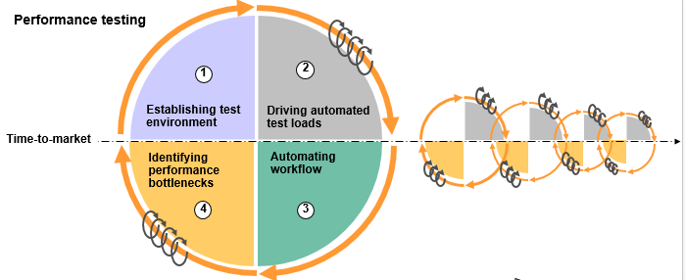

**Purpose:-**

* It can demonstrate that the EY system meets performance criteria
* It can compare two systems to find which performs better
* It can measure what parts of the system or workload cause the system to perform badly
* To measure transaction response time for defined business tasks/scenarios
* To determine workload throughput capabilities of the system
* To identify bottlenecks within the system where performance degrades

**Why Performance Testing Is Needed:-**

* Will EY application meet the defined response-time requirements of my customers?
* Will EY users experience acceptable response times, even during peak hours?
* What system capacity is required to handle expected load?
* Where are the bottlenecks in my multi-user environment?
* How can we detect errors that only occur under real-load conditions?
* How can we optimize the multi-user application before it goes live?

**Key Areas of Performance Testing**

The Top 9 key areas that will be performed in EY by MTS are described in this approach document to address the following areas of performance testing:

* Defining performance requirements
* Establishing production-like test environment
* Managing performance data
* Creating workload mix profiles
* Categorize performance test runs
* Maintaining test run logs
* Performance analysis and tuning
* Documenting final performance reports

**Defining Performance Requirements:**

Understanding the performance requirements is one of the most important factors in the performance testing process. The establishment of well-defined requirements is critical for the following reasons:

* It assures that all parties i.e. service provider and customer are clear on the scope of testing
* Allows the MTS test team to identify the types of workload test tools required for the performance test
* Can off-the-shelf workload tools be purchased or open sourced
* Will custom-developed workload tools be required
* Allows the test team to identify the types of performance monitoring and analysis tools required.

Performance requirements will identify the nature of the application(s) being evaluated, whether it is a web application, online transaction processing (OLTP) application, batch application, or some combination of the above. The requirements should be highly detailed, identifying:

* Representative EY business tasks or business usage scenarios performed by end users of the application
* Roles of end users (e.g. general user, administrator, auditor, approver)
* The number of users that perform each role/scenario
* User entry points to the application (e.g. Internal, external)
* The number of users that will be serviced at the busiest deployment location, given worldwide deployment plans for the application
* Growth in number of users and business tasks (usage scenarios) for the next six to twelve months of the application
* The number of times each business task will performed by each user (per hour or week or month or year)
* The type of background processes and workloads the application will be subjected against
* Data requirements relative to the identified business tasks for the application study
* Response time requirements
* Production server environment architecture
* Network/Proxy/Firewall considerations
* Middleware software versions required by the application

**Does the project have performance requirements defined already?**

**Yes - >** Some projects in EY create documentation to define the performance objectives of their application. These documents are oftentimes called “Non-Functional Requirements” or NFR. NFRs are the Focus of performance testing. Below is an example of the difference between a functional and non-functional requirement:

* **Functional Requirement**: Validate that a user can create a PNR for specific origin and destination
* **Non Functional Requirement**: The PNR should generate within 3 – 4 seconds once the action submitted by the user. These SLA’s should also meet with single user/multiple/concurrent users and the server stats should be in acceptable range

**No - >** If the project in EY does not have requirements defined, then IBM MTS will consider doing the following:

* Provide EY a requirements questionnaire:

The questions should trigger answers that once collected will give the performance team a comprehensive view of the application performance requirements

* Conduct a series of face-to-face work sessions with the Customer Business Analyst team and Application Architects to define requirements

Once all requirements have been identified and test scenarios/cases defined, map the planned test scenarios against each requirement.

**Establishing production-like test environment:**

To know the expected performance of EY applications, MTS will conduct the performance testing on a PPE environment that closely resembles the planned production infrastructure. Specifically:

* Physical server layout for applications (e.g. what applications run on which server)
* The hardware configuration of each server (e.g. CPU quantity and type, memory, hard disks, etc.)
* J2EE application server configuration (i.e. IBM Web Sphere, BEA Web Logic, etc.)
* Physical layout
* Cell Topology
* Cluster Configuration
* Edge Server and HTTP Server configuration
* JVM (Java Virtual Machine) Server configuration
* Message Oriented server Queue Manager and Cluster configuration (i.e. IBM Web Sphere MQ)
* Operating System and Middleware software versions
* Network WAN and LAN topology
* Database servers
* Storage devices

**Managing Performance Data:**

Test data is an important factor in the equation for helping to yield a successful performance test. Below are three associated practices MTS will consider while planning for Test Data for NFT

**Production data volumes:**

It is important to have the databases within our performance PPE environment setup with a volume of data equivalent to that of Production. The physical size (i.e. content) of EY database tables can significantly impact the results of our performance testing. Test results for business scenarios that range from online transactions (e.g. Web), batch related transactions, or to database replication events, will be impacted by the size of the database. The process of tuning database configuration parameters such as buffer pool sizes, or optimizing long-running queries by adding table indexes will mean little unless the database size is production equivalent. So IBM MTS will ensure that EY PPE environment is loaded with the correct volume of data to better understand the expected performance in production.

IBM MTS team will work with EY Application Architect and DBA (Database Administrator) on ways to build a test environment database that matches production. One possible solution is to restore a backup image of the production database. If a production database backup is not available (Note: it may not exist for a new application), then the database contents would be generated via alternate means.

**Creating workload mix profiles:**

As a result of defining the performance test requirements, all business scenarios have been identified. Next, it is important to formulate a model or profile that depicts how the business scenarios will be executed concurrently for a performance test which is called as a workload mix. Workload mix profiles lend primarily to non-batch oriented performance testing. Below are the elements that are critical when building a workload mix. These include:

* **Business Scenarios:** These are the business tasks (scenarios) identified for users of the application
* **Transaction Steps**: These are the individual elements (steps) that comprise a business scenario. Performance response time is typically measured at the transaction level. For example: Business Scenario for “PNR creation” is: 1) Navigate to Etihad.com, 2) Enter Origin and Destination, 3) Click on search, 4) Payment confirmation, 5) PNR confirmation
* **Run Time:** Performance runs should typically be scheduled for 60 minutes. This excludes the time to ramp-up (start) all users at the beginning of a test and the time for all users to stop
* **Peak Hour Volume:** For each business scenario, the test requirements should identify the number of times each scenario is performed for a specific timeframe (by hour, week, or month). An hourly volume target value should be derived from this prod data. Consequently, this volume should represent the highest hourly volume expected in production for the given scenario. Note: The term “Load” or “Throughput” is often substituted for the word “Volume” when used in this context
* **Concurrent Users:** This is the number of users, or virtual users, required for each business scenario when executing a test to achieve the targeted peak hour volume. The number of required users should be defined for each business scenario by the business/from existing prod stats
* **Scenario Ratios:** This is a business defined value which identifies a ratio of how many times each business scenario is executed relative to the other business scenarios which are running concurrently. For example: Two scenarios are executed concurrently; Scenario1 is performed 70% of the time; Scenario2 is performed 30% of the time
* Think Time: This is a reference to the time involved while a user pauses at the keyboard before proceeding to the next transaction step
* Average Session Duration: This is the average time required to execute one cycle (iteration) of all business scenario transaction steps, including user think time.
* Pacing Time: This is the amount of time a user waits before starting another scenario iteration
* 100% (1X) Workload: This is also called Peak Hour Workload. It represents the total number of concurrent users, total number of business scenario iterations (volume), scenario ratios, and average session duration required during the Peak Hour

Now that we have defined these key elements, below is an example of a workload mix profile. If we adopt the practice of building workload profiles, we will discover the value when assembling test schedules in order to execute all scenarios running concurrently. The profile will remain as a continual reference throughout our test execution phase

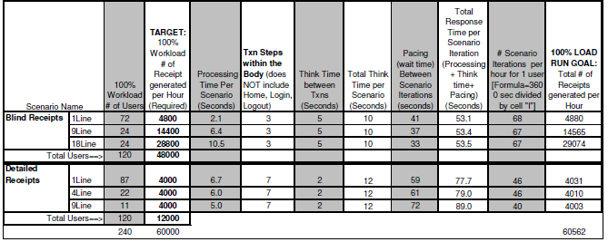

**Categories of Performance Testing:**

Performance test runs can be classified into test execution categories. These categories provide the scope and objectives of our planned performance runs. Consequently, we all will have a better understanding of the performance test execution strategy. IBM MTS will be carrying out the performance tests based on the project requirement

***Baseline Testing:***

* Single User testing.
* Run each business scenario in isolation against the application. In other words, there is no competing workload taking place on the test environment.
* The objective of the test is:
* Establish a “best case” response time baseline for each transaction step.
* Run each scenario a minimum of “N” times to provide statistically valid sample size
  + Note: Ensure system is “warm” before starting (cache/buffers are loaded, etc.)
* Identify application problems at an early stage. A majority of poor performance at the
* Single user level points to application design problems or database query issues.

***Peak Hour Testing:***

* Peak Hour Workload or “100% (1X) Workload” testing.
* It represents the total number of concurrent users, total number of business scenario iterations, scenario ratios, and average session duration required during the Peak Hour.
* The Peak Hour Workload test (1X Test) will establish the baseline for all business scenarios running concurrently in a mixed load.
* The duration of this test should be one hour. This excludes the time to ramp-up (start) all users, plus any additional time required for system “warm-up”.
* Assuming no performance issues are identified, the test should be executed 3 times to validate the results and ensure repeatability.
* During the Peak Hour Workload testing, the system resources should be monitored for performance issues. These statistics will also be helpful for capacity planning purposes.

***Scalability Testing:***

* These tests will measure the performance of each business scenario running concurrently with incrementally increased workload levels.
* Assuming the 1X (Peak Hour) workload volume can be achieved with no significant performance issues, additional tests will be run based on multiples of the 1X workload volume. Begin running 2X workload volumes, increase to 3X workload volume, etc., while analyzing the system and business scenario behavior to identify “performance bottlenecks” within the application.
* The duration of this test should be one hour, excluding user ramp-up time.
* Scalability testing can also be labeled as “Break Point Testing” or “Stress Testing”. Continue multiplying the Peak Hour (total number of transactions and concurrent users) until the breaking point or the maximum system capacity is reached. Please see example graph below

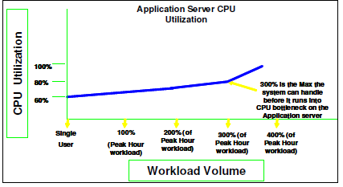

***Batch Job Testing:***

* The test will measure the throughput rate and time required to complete a batch job.
* There is no specific time duration for this test, since one of the performance objectives could be to determine if the batch job will fit into a pre-defined time window (e.g. like a system maintenance window).
* System resources should be monitored and performance statistics collected for analysis
* All performance bottlenecks should be addressed and a set of recommendations provided.

***Interference Testing:***

* The objective of this test is to measure the impact to online response time transactions while running batch jobs as interference. Batch jobs are typically run during non-prime (off shift) business hours. Sometimes, however, batch schedules overlap into prime hours and can have an impact on online user transactions.
* Run the Peak Hour Workload test (1X Test) while processing batch jobs.
* Average response time for each transaction should be collected and the system resources monitored and performance statistics gathered. This data should be analyzed against the Peak Hour Workload test baseline.
* All Performance bottlenecks should be addressed and a set of recommendations provided.

***Endurance Testing:***

* One of the primary objectives of Endurance Testing is to identify memory leaks within the application.
* Endurance testing can be classified into two categories:
  + Reliability Test: This test will demonstrate that the system does not break down when the workload offering is continuously processed for a 4-hour duration. Run the Peak Hour Workload test or a higher multiple (e.g. 2X, 3X) of this workload that does not overload system capacity.
  + Long Duration/soak Test: Run the Peak Hour Workload for 24 to 48 continuous hours to identify memory leaks and application stability issues.

***Failover testing:***

Failover Tests verify of redundancy mechanisms while the system is under load. This is in contrast to Load Tests which are conducted under different load with no component failure during the course of a test. Failover testing will allow us to address problems in advance, it also provides a baseline of failover capability so that a server can be shutdown with confidence, in the knowledge that the remaining infrastructure will cope with the surge of failover load, below is the pictorial representation of the failover scenario

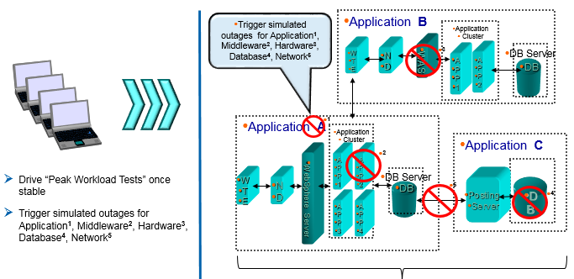

**Performance Analysis/Tuning Runs:**

* The objective is to execute workload tests while evaluating application, database, and system (hardware, O/S, middleware software) performance.
* Performance tool metrics will be collected from these runs and analyzed by the Performance Test Analysts, Environment Support teams, and Application Development teams.
* Where performance bottlenecks are identified, root causal analysis will be performed.
* Subsequent tuning changes will be made, such as modifying middleware software tuning parameters, and additional test runs executed to evaluate the impact of the changes
* Few of the server stats which are monitored are CPU, Memory, I/o, Disk, Connection pool and network stats

**Maintaining test run logs:**

IMTS will create test run logs and maintained during the performance test execution phase. The objective of the run logs is to serve as an audit trail of the work performed during our performance test. Building a spreadsheet for the run log is a simple and acceptable solution.

Unlike functional testing, the nature of performance testing is that a particular Workload Test can be executed repeatedly throughout the test execution phase. For example, if we are conducting debug to isolate functional issues or performance bottlenecks, we will make multiple runs using the same workload test. We will also repeat the workload runs while conducting application performance tuning. Consequently, it is important to maintain a historical reference of these runs to denote key events like code builds used, defects opened, changes made before the runs, and general observations after the runs.

An example test run log is provided below for reference. Special note: If we have a large scale performance test covering a broad range of application components (functional areas), consider creating a separate test run log for each area being evaluated

**Performance analysis and tuning:**

There are two primary activities taking place during the Test Execution phase:

* Making performance test runs by using automated load test tools to drive test scripts
* Analyzing test run results for purposes of identifying bottlenecks and tuning the application(s) for better performance.

Tuning an application is an exercise that will be conducted jointly with members of the Application Development team, Environment Support team (System and Database Administrators), and the MTS Performance Analyst from the Test team.

Once the PPE environment is built, MTS will ensure the Environment Support team applies the middleware software configuration parameter values as used in Production. If the application is new, meaning it has never been implemented in a production setting, than we will begin our testing using the default values assigned to these configurable parameters (unless our Environment Support team or Application Architects choose to modify some of these settings before testing begins). Throughout the test execution phase, these parameters will be “tuned” in order for the application to achieve optimum performance based on the Workload tests being generated.

It is important to document and track the values of these middleware software tuning parameters throughout the test execution phase. Capture the values in our test run logs to show configuration changes made prior to our debug and/or performance tuning validation workload tests. Once the testing process is complete, we will produce a Tuning Guide that reveals the final settings for these configurable parameters. This Tuning Guide should be used as a reference document by the Environment Support team to ensure the settings are applied to production before it goes live. Here is an example of a performance Tuning Guide entry for two middleware software components (Web Sphere MQ and IHS):

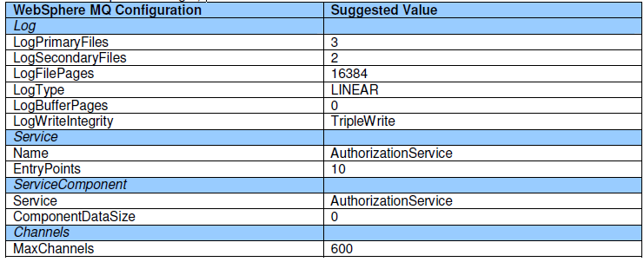

**Documenting final performance reports:**

So much can change, and typically does, between the times when the initial Test Plan was developed and when the last test run would executed. Certain test runs may have been forecasted in the initial test plan. But due to such factors as time constraints and/or reaching workload/system performance constraints before anticipated, it is unlikely that our final test run activities will map one-for-one to our initial Test Plan.

For example, our team may have spent 10 weeks (out of a 10 week test schedule) identifying bottlenecks and tuning the performance for one specific workload test. Thus, no schedule time was allowed to execute the remaining workload test runs. As another example, you may have planned Scalable workload test runs (i.e. 2X, 3X, etc.). But insufficient system resources (high CPU utilization) prevented running any workload greater than Peak Hour (1X) volume.

Therefore, it is important to reflect the actual events conducted and results obtained during our test execution phase. Presented below is a report outline, or guideline, for the minimal set of information to include in a final performance test report.

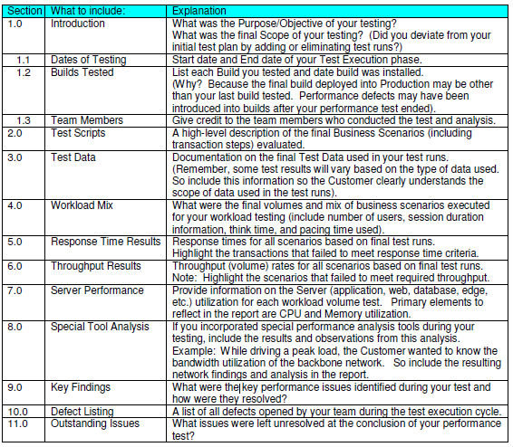

**Automation Testing**

Automation testing activity will involve creation of automated Regression scripts for different Etihad applications under testing scope, on which test execution needs to be done frequently to ensure that the system behaves correctly and meets user requirements as specified. Automation will be done using IBM Rational Functional Tester (RFT) tool.

The automation includes main two type of activity:-

1) Automation of New Application

2) Modification / update of existing automated scripts.

**Approach:**

A Keyword driven Automation framework will be followed, which will make the scripts highly reusable and easily maintainable, unless there is an exception approval for record and play back option or there are limitations where keyword driven approach is not supported

**Proposed Solution for Test Automation**

Etihad has a wide range of different application spread across different work streams like Airport Operations, Corporate, Reservations & Commercial and being a mix of web Based and Standalone desktop applications. Some cases the requirement is to run the same application across multiple browser and for different site editions which caters to different language options.

In order to automate test cases across the various domains /platform/browser/languages the approach that is being taken is a Component Based Data Driven Framework which will stores the Test Data – (All the environment related data and data that will be used during execution), Test Case List for iterative execution in a shared location stored in external Excel sheet. Dynamic Reusable Business Components Script for respective applications dividing the full Business follow into smaller dynamic reusable business components.

Data driving the Test Component Based Data Driven Framework does solve data hard coding issue but then it opens Pandora’s Box with lot many difficulties to overcome - script complexity on the rise, automation implementation time increasing by 1.5 – 2 times per script to name some of the issues.

Five RFT Scripts – Read_Excel, Common_Function, Reusable_Function, Driver_Script and Generate_Log, will be created to read the data from the External Automation Driver sheet in order to create automated script and execution. For interacting with external Excel files jxl-2.6.jar and org.apache.poi-osgi-3.8.jar file will be used in this Framework.

Pictorial depiction of the Framework that will be implemented for Etihad –

START

Global Driver

Script

Test Environment Properties

Driver

Test Steps

Test

Test Case

Test Scripts Selection

Driver

Action Module

Application

Under Test

VP Scripts Based on TC / TS

Reusable Dynamic Business Component / Library Functions Scripts

STOP

Datapool

Data Items

Excel Report Write

Framework Folder Structure:

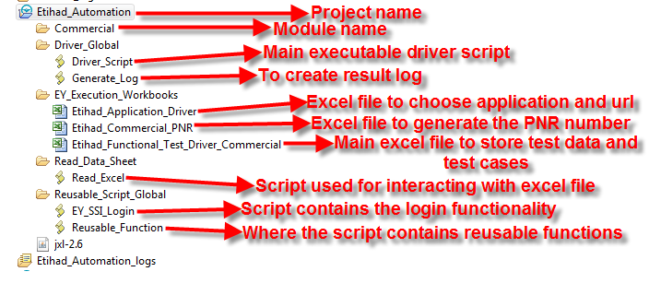

**Module Structure:-**

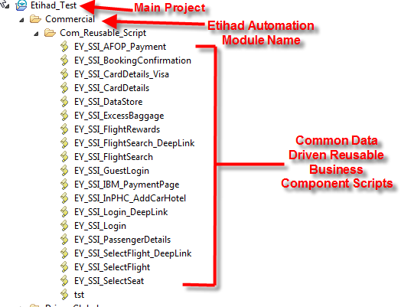

**Execution Process to be followed to run the Test cases**

**Step1:**

Etihad_Application_Driver.xls:- When Driver script is given for execution, first it will read the ‘AppName’ sheet from Etihad_Application_Driver excel to fetch the Application Name and URL.

Etihad_Application_Driver excel file needs to be opened and the application name to be provided in Application Name column, URL in App_Url column and ‘Y’ in Run_Flag column as depicted below.

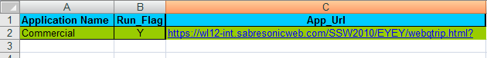

In this excel ‘**AppName**’ sheet will contain the Application name, Run_Flag and App_Url columns.

**Application name:**  Current application name which will be run.

**Run_Flag:-** Tester will need to mention the run_flag as ‘Y’ to choose application.

**App_Url:-** Will give the the application url.

**Note:-** The application name in ‘**AppName**’ sheet should be same with the application name in Driver_Script.java. If any new application comes then application name needs to be added in ‘**AppName**’ sheet and as well as the else condition should be included in the **Driver_Script.java**.

**Step 2:**

**Etihad_<Application Name>_PNR:** This excel file will store the PNR number or other data which is generated or need to store by the automation script during execution for future reference or use.

**Step3:**

**Etihad_Functional_Test_Driver_<Application Name>.xls:** This excel file will contain six sheets like below.

1. Environment

2. RunDriver

3. TestData

4. CallScript

5. Result_Log

6. Result_Details

7. MultiLanguage (Optional: for running multiple Language)

Below is the excel format:



**1. Environment:**  This sheet will have the Browsers with Web Language information which describes on which browser execution needs to run the test Cases in next/current execution cycle.

**Below is the format:** 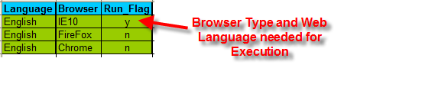

**2. Run Driver:** This sheet will store all the test cases corresponding from different modules, sub-modules names and manual test case names. In simple terms, this is our **Test Execution plan for Automation in Tabular** form. To run the test case, needs to give **Run_Status** as ‘**Y**’ against the **Automation_ScriptName** intended for execution. This sheet will store all the test cases corresponding from different modules, sub-modules names and manual test case names. In simple terms, this is our Test Execution plan for Automation in Tabular form. If we want to run the test case then we have to give Run_Status as ‘Y’ in front of Automation_ScriptName. We have to provide short summary Description for test case which actually gives the purpose of the test case.

Below is the format:

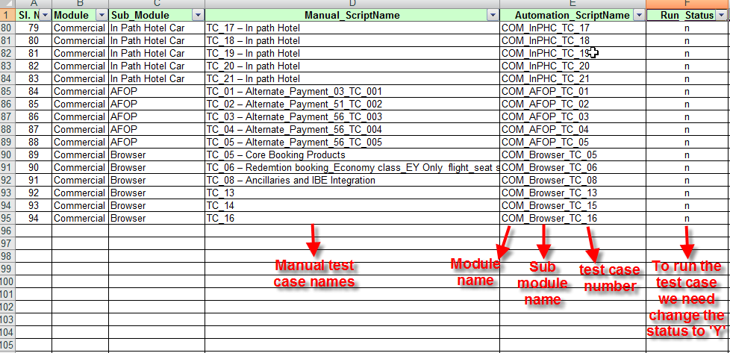

**3. Test Data:** This spreadsheet will store all the Test Data required for all the test cases (in Keyword form) for the type of Action one will perform in each step with data which needs to be inserted. If all the rows are exhausted from one column, a new set of columns just beside to the existing ones will be used. Below is the format of Driver sheet.

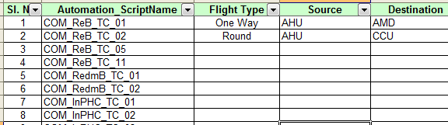

**4. Call Scripts:** This sheet will contain Automation script name, module name & components called as re-usable scripts. Before running the test cases components (reusable scripts) will be mapped to the corresponding automation script names and module names. Components are the re-usable scripts which will be developed before the to map in excel.

**The <Application Name>_CallScripts format :**

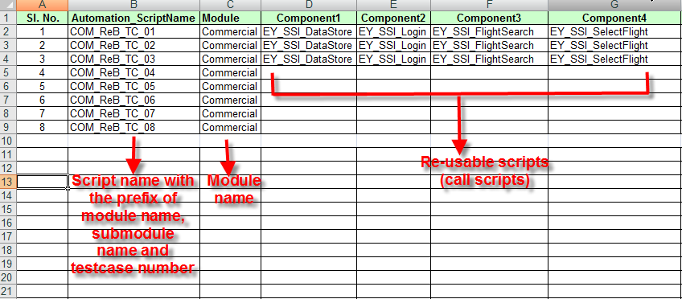

The Driver_Script is the executable script. The driver script will have to be run to execute the selected test cases as depicted below :

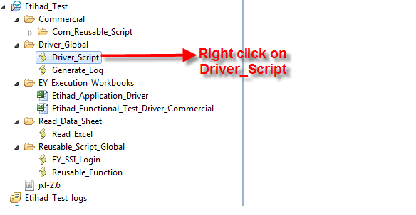

After right click on **Driver_Script** below window will be displayed:

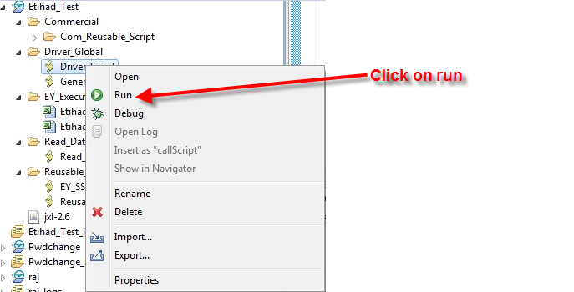

On clicking on Run below window should be displayed:

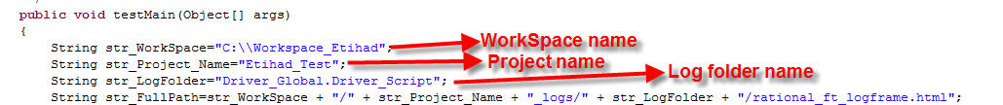

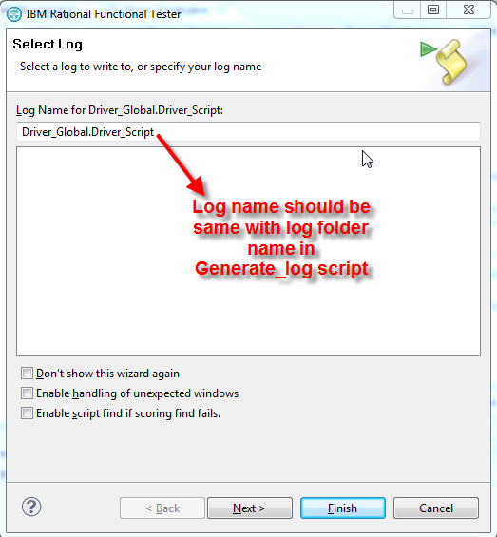

The log name will have to be checked on select log window to verify whether it is same with the log folder in Generate_log.java file. To execute the driver script the finish button needs to be clicked.

**5. Result_Log:-** This sheet will store the Automation Test Execution results details with Status, Script name, Test Case Description, Start time, End time, Error Message, Step Count and Batch Start Time once the test cases running finished. In Start Time and End Time column it gives each test script execution start and end time details. It generates the results from Generate_Log script, so in the script needs to give the proper Workspace name, Project name and Log folder like below:



**6. Result_Details:** This sheet will contain details of different object action performed for each Automation script by providing **Object Name, Object Action, Test Data Value, Status, Error Message and Execution Time** details in corresponding column.

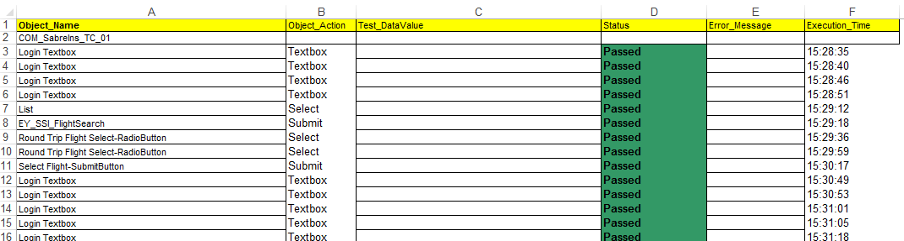

**Creation of new scripts in RFT using Etihad framework**

**Prerequisite:** The component scripts (reusable scripts) will be developed first before designing the automation test scripts. Following steps will be involved:

1. Analysis of the manual test cases.
2. Understanding the flow/functionality of the manual test cases.
3. Components development, which are called as reusable scripts and mapping of the components with **Automation_ScriptName** and **Module** name in CallScripts sheet like below. These scripts we have to maintain under **Com_Reusable_Script** folder of Etihad project.



1. Here automation script name should be the prefix of module name, sub module name and test case number.
2. If any new application/module comes, needs to enter that application/module name in **AppName** sheet of **Etihad_Application_Driver** excel. Now the same application/module names we have to enter in **CallScripts** sheet of **Etihad_Functional_Test_Driver_<Application Name>** excel.
3. Now the test data for each test case needs to needs entered in the TestData sheet.
4. Module, Sub Module names with manual test case names are entered along with Automation script names in **RunDriver** sheet. If any test case needs to run, run status as ‘y’ needs to be mentioned for that particular test case.
5. Environment details like language, browser name and Run_Flag needs to be mentioned in Environment sheet.

**Process to be followed to import the JXL jar file:**

**Step 1:** In RFT from File->New->Functional Test Project

**Step 2:** Enter Project Name (<Etihad_Automation>)

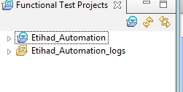

**Step 3:** Select the project and right-click. Select Import. Select General->Archive File

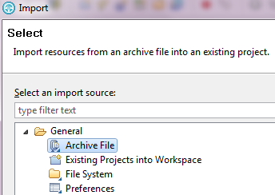

Click Next. Select the attached Archive File. Select all except Log File.

**Step 4:** Again select the Project. Right Click go to Properties. Select Java Build Path and select Add External JARs to add JXL API in the project to use jxl API. Click OK.

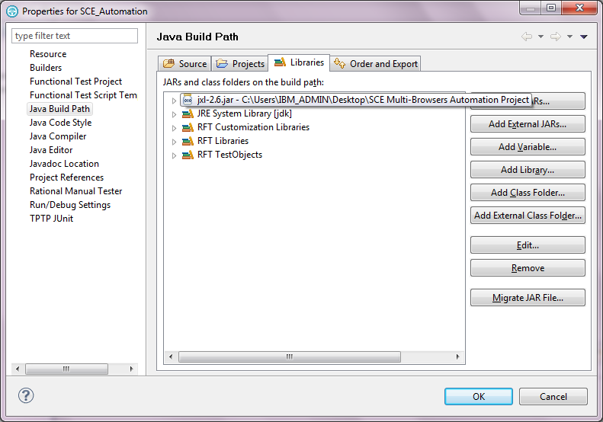

**Step 5:** Need to Place the <project> Automation Sheet in the C:\ Drive.

**Step 6:** Need to fill the Automation Sheet with Module, Sub-Module, Manual Test Case names and test data values in RunDriver sheet and TestData.

**Step 7:** Need to Select Driver_Script and click execute. Automation suite/programs will automatically run.

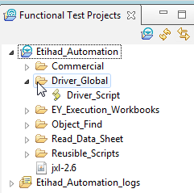

**Process to be followed to Capture Object Property- Value**

**Step 1:** Run the AUT. Here www.etihad.com (portal web site) is used.

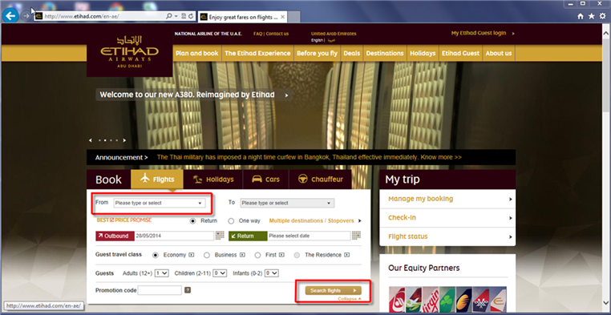

**Step 2:** Let say Tester wants to test the functionality of the Flight Search. First tester has to capture the object properties-values of the From Drop-Down list. To do so tester has to open the RFT Test Object Inspector and hover the mouse icon on the object (here search) and press “SHIFT”. Below figure shows the same.

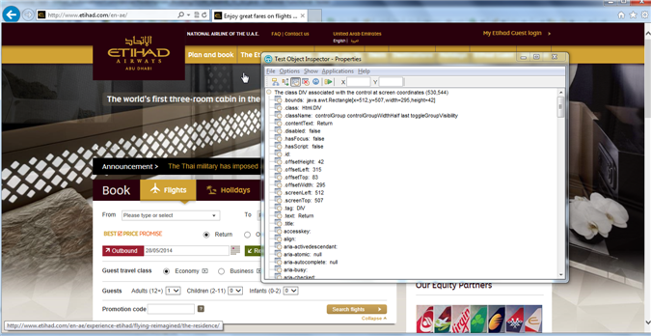

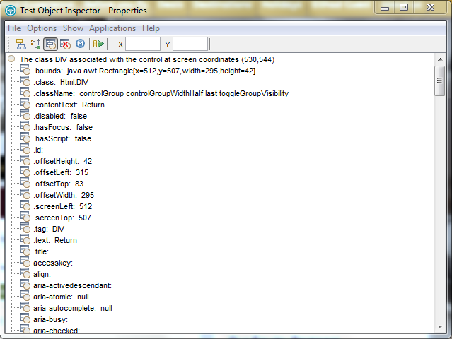

**Step 2A:** To know the weight value of the properties of the object tester needs to take help of RFT Object Map. Please have a look below steps for the same.

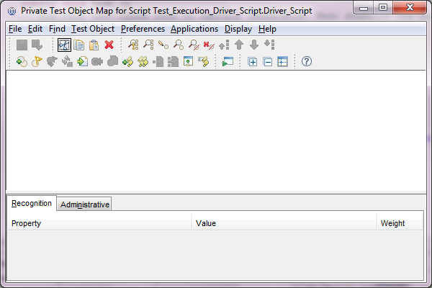

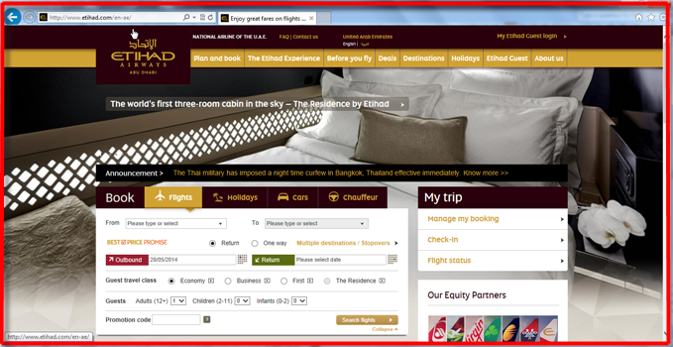

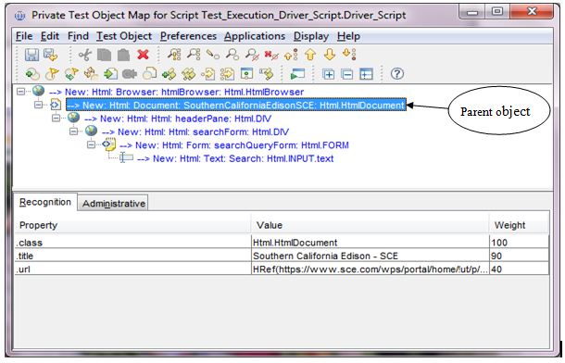

Take the .title property of the Parent Object of any GUI Test Object and put the same as the Page Name column in out Object sheet with a ‘_’ and number (for to make individual identity of objects located in same page). For example if in Home Page has 50 objects then the page names should be HomePage_1, HomePage_2, HomePage_3…HomePage_50 respectively.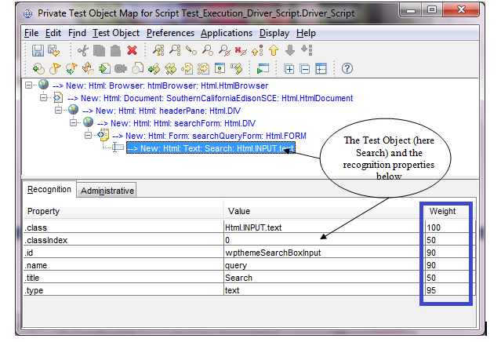Take the **.class** and **.classIndex** properties and any other third property. Please decide to choose the property based on the **Weight value of each property** and put those in the sheet in proper column.

**GUI_Name** (as it appears in the web page) should be the Descriptive Name of the Object (located in Administrative Property Section)

**Obj_Type** should be the Test Object Class Name of the Object (located in Administrative Property Section)

**Process to be followed to perform Manual Object Verification and Validation**

Let’s take one example: Verify that "**Search flights" button should be displayed at the Etihad Home Page.** Please see below that needs to verify the visible text at the search engine should be “Search” during our execution of the AUT.



**How will the Test Team benefit from this Framework?**

**Step 1:** Test Team will first need to know or identify which for which object (if any) they will need to plan a verification point.

**Step 2:** In the test script, “Verification” Point will need to be included for the object considered in the Page (Parent) name in which the object resides.

**Introduction of Test Data Pool Concept**

A datapool is a collection of related data records, which supplies data values to the variables in a test script during playback. The datapool can be used in various ways (here Microsoft Excel Datapool will be used) in the framework to make the process more efficient; when strategically used, this capability can help reduce the code size, and assist in furthering effective automation efforts.

The data in the datapool can be changed anytime, without any need to modify your framework, which helps make your framework flexible for changes.

To do so the approach that will be followed is noted below:

**Driver Worksheet:**

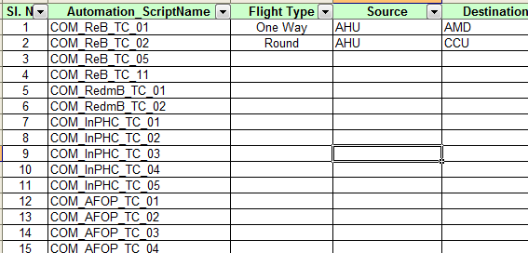

Driver Script Snapshot for reading the datapool worksheet:

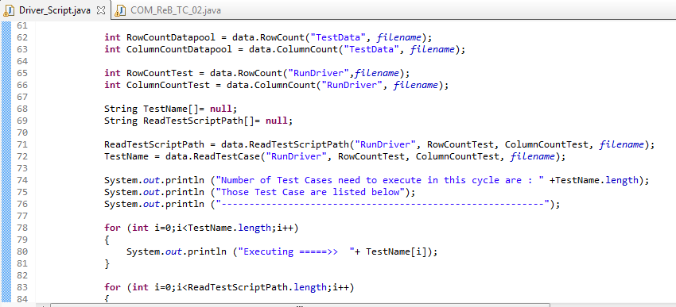

TestDatatmp will take the column name and then ReadDatapool method will search the column in Datapool worksheet and read the data items one by one.

**Automation Execution Report**

Generating execution result report will be very important for not only Automation Testing but also for Manual Testing also. Generally execution report will be sent in Microsoft Excel Worksheet to analyze RFT Log. In this way the report has to be prepared manually.

**RFT Result:**

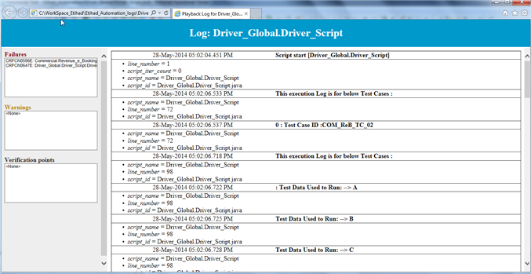

**Quantitative Benefits of this Framework**

The various quantitative benefits of this framework are –

* Maintenance changes like change in object property or change in test case workflow can be reduced to a fixed time of only 10 Minutes or 0.15 hour per change in property value or per workflow change of a test case.
* Time to develop a test case with moderate complexity (~25 steps) will be reduced from standard 4 hours to 2 hours with all 25 steps being new steps and involving 20+ new objects. I.e. a reduction of 50% in script automation time. If the steps or objects are common with existing test case or document, this time has the potential to reduce by as much as 90-95%.
* Skill level needed in automation to develop scripts reduced to very little as 80% of the scenarios or workflows will be covered in component scripts itself. Only verification point script needs to be prepared by test script developer.
* The main scripts code is already prepared and attached as object below. This code can be directly copied for automating any project application. Thus once prepared, this code has the capability to reduce the test script preparation task to filling up Automation excel sheet and verification points (which are actually very local to test case objective).
* Test Script and automation framework knowledge transfer duration for this framework for any application is 6 hours maximum. As the test scripts are based on keyword and will look as manual test case steps in excel sheet for any new test application programmer, quality analyst or any other stakeholder.
* Review of test case workflow by business analyst or by subject matter expert is reduced by 40-60%. Since the test steps are in broken into component scripts, it can be reviewed quickly and easily with or without RFT tool knowledge.

**Qualitative Benefits of this Framework**

* + This framework’s strongest qualitative benefit is – it is independent of Applications current state. If application is in development phase still with only wireframe diagrams and use cases regression pack can be developed with inputs from development team about objects properties inserted in application. Thus even if application is not in baseline state, regression scripts can be developed. For verification point, Manual VP’s could be inserted or scripted.
  + Easier and understandable to new users, business analysts, Developer and all stakeholders involved.
  + Easy to present the test information workflow to business analyst for review.
  + Scripting performed in Standard English reduces complexity of test cases. From top it will look as a set of manual test case steps without the need of sentence formation.
  + Basic automation skill needed. Only skill needed is to create verification point or special scenarios scripts.
  + Fastest method to create automation test scripts in any Reusable Framework Architecture (Considering Record and Playback non-reusable framework)
  + Scripts executed through batch files can be scheduled for execution via different methods.
  + Consistent: The same keyword is used to describe the business event every time.
  + Self-Documenting: The keyword description contains the details of the designer’s intent.

**Assumptions, Constraints and Dependencies**

**Assumptions**

Following are the assumptions that will be considered while automating test cases using RFT:

* All the objects of the application to be tested using RFT can be identified normally. Special cases could be there and added to Reusable Function scripts section, but at least the tool should be able to identify the objects.
* MS Excel is available in the same server/shared server where Automation sheet is to be built with Admin access.
* The total number of test cases and their steps in entire test suite can be incorporated in Driver sheet.
* Objects from AUT are less than 65536, i.e. row limit in excel. However this can be overcome by little tweaking in code.

**Constraints**

Following are the constraints that will need to be considered while automating test cases using RFT:

JExcelApi method used in this framework will read workbooks created in Excel 95, 97 and 2000, and will generate workbooks that can be read by Excel 97 and later.

* This Framework will work for only Multi-Browsers, Multi-Domains Web Application Testing in PC (Windows) environment not for any Mobile Device (Apple, Google, Samsung etc.) environment.

**Dependencies**

Following are the dependencies that needs to be met before automating test cases using RFT:

Action names and Object Names are case sensitive.

* Object names in driver sheet should be exactly same as the one mentioned in Object sheet.
* Jxl.jar file should be added in RFT library.
* User should have admin access rights on excel file.

**Test Process**

**Waterfall Model**

The following swim lane will provide an overview of the general test process being followed across all work stream in Etihad for Functional Testing where SDLC follows a waterfall model.

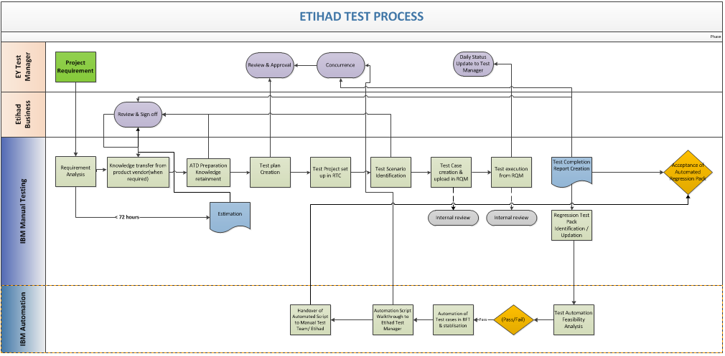

**Agile Model**

The following swim lane will provide an overview of the general test process being followed across all work stream in Etihad for Functional Testing where SDLC follows a Agile model.



**Entry / Exit Criteria**

The Entry and Exit criteria for the Etihad Managed Testing Services will be a set of conditions that should be met in order to commence and close a particular project test phase or stage. Each test phase will have one of more entry and exit criteria conditions defined, documented and signed-off.

**Entry Criteria:**

|  |  |
| --- | --- |
| Item | Owner |
| Requirements are baseline and approved. Requirement document is available with all stakeholders | EY Project Managers |
| Detailed Design, Development and Solution Architecture documentation approved, with special focus on the interface specifications (Either as part of Requirement document or a separate artefact) | EY Project Managers |
| Detailed design and development is complete- including 100% of agreed functionality (Design + Development Signoff) | EY Project Managers |
| All planned tests in Unit/Component testing are complete and all components are covered | EY Project Managers |
| Unit/Component Testing exit criteria are met and risks for open issues assessed and shared. | EY Project Managers |
| Test Plan for the release is shared with all stakeholders and approved | IBM Test Leads |
| Open Issues from Unit/Component Test are incorporated into the Test Plan | EY Project Managers, Test Managers, IBM Test Leads |
| Requirement Traceability Matrix from Requirement to Design and up to Unit/Component Testing is complete and provided | EY Project Managers |
| Test –Requirement Traceability Matrix is complete - all test requirements cover the system / functional requirements and all test cases map to test requirements | IBM Test Leads |
| All Release Test cases are designed, scripted and planned in current Test Management tool | IBM Test Leads |
| Test Execution Readiness Review is complete   * Test Execution Plan is complete * Test data activities (planning, creation, configuration) complete * Release Notes approved and delivered * Test Environment is ready and Build completed for all Impacted Systems * Build Pack Confirmed * Configuration and Change Control in place for fixes or changes | * IBM Test Leads * IBM Test Leads * EY Project Managers, Test Managers * Test Managers * Test Managers * EY Project Managers, Test Managers |
| Defect Management Process in place and communicated to stakeholders | Test Managers, IBM Test Leads |
| Sanity Test of Deployment is complete | Test Managers, IBM Test Leads |
| Impact analysis for any CR and Defect Fixes available. | EY Project Manager |
| Test Support Contact Points from all stakeholders are available. | EY Project Manager, Test Managers |
| Test Plan re-baseline due to changes in Key Inputs or impacts from CRs, Defects and Execution activities | IBM Test Leads |

**Exit Criteria:**

|  |  |
| --- | --- |
| Item | Owner |
| All Release Test Cases have been executed with following exceptions   * Mutually agreed with stakeholders to be withdrawn * Additional Risk agreed with stakeholders with Risk Signoff form | IBM Test Leads |
| Release Test cases are updated with results of execution | IBM Test Leads |
| Defects and Outstanding Requirement issues are documented and signed off | EY Project Manager, Test Manager, IBM Test Lead |
| No Outstanding Critical, Very High or High Defects are open. | EY Project Manager, Test Manager, IBM Test Lead |
| All Outstanding Low and Medium Defects have an action plan to resolve and plan to meet turnaround times | EY Project Manager, Test Manager |
| Requirement Coverage is complete as per signed off risk coverage in Test Plan | IBM Test Lead |
| Requirement – Test - Defect Traceability available | IBM Test Lead |
| Test Plan Variations captured in Test Completion Report | IBM Test Lead |
| Release test report(TCR) delivered to EY Project Manager | Test Manager, IBM Test Lead |
| TCR is signed off by Business Stakeholders | Test Manager, EY Project Manager |

**Tools**

IBM will be using the following Tools to support all testing activities performed for Etihad Managed Test Service:

| **Tool** | **Used For** |
| --- | --- |
| IBM Rational Quality Manager | Test Management & Functional Test Execution |
| IBM Rational team concert | Document Management, Issue & Risk Management, Defect Management |
| IBM Rational Functional Tester | Automation of Functional Test Cases |
| IBM Rational Performance Tester | Non Functional Testing |
| IBM Rational Test Workbench | Mobile Test Automation |

**Metrics**

MTS will work on a collaborative approach with stakeholders on Key Metrics Measurement for Testing. Below is the list of measurements. As per change management process, Specific KPI as well as Minimum and Target KPIs would be adjusted periodically based on current measurement and business needs.

| SPI Category | SPI | Definition | Minimum  KPI | Target  KPI |
| --- | --- | --- | --- | --- |
| Productivity | Defect Removal efficiency -  Quality | The number of defects found in Quality  Assurance (‘QA’) by the test team versus the  total number of defects found in QA  environment (test team + UAT); | 93% | 95% |
| Productivity | Defect Removal efficiency – Quantity | The number of defects found pre implementation versus the total number of defects (production) | 95% | 97% |
| Timeliness | Test Progress Ratio | Actual tests executed compared to test planned. | 94% | 96% |
| Timeliness | Adherence to Delivery Dates | A agreed %’age of deliverables within the agreed timeframe | 95% | 97% |
| Effectiveness | Test effectiveness | The number of defects found divided by number of test cases executed; | 96% | 98% |
| Automation | Automation efficiency | The number of automated test cases executed versus the total test cases executed | 25% | 40% |

**Test Management and Reporting**

Test Management will be done through Rational Quality Manager. Test Plan, Test Cases, Traceability, Test Execution Records and Defect Linking will be performed in RQM and reports generated out of it as and when required.

Additionally following reporting templates will be used to report at various stages of testing lifecycle:

Test Estimation Template (For SIT & NFT):



Requirement Traceability Matrix:



Test Plan Templates (For SIT & NFT):



Test Completion Report (SIT, STAN OR P2s, NFT):

  

**Defect Management**

The following Defect Management process will be followed across all work streams under Etihad Managed Test Service. Rational Team Concert (RTC) will be extensively used as a Defect Management and Tracking tool.

Etihad Test Managers, Development Team, Project Team, Product Vendors will have access to RTC for viewing and updating defects logged during Test Execution.

Where Product Vendors will have their own defect management tool, IBM Test Team should log a defect in RTC and duplicate in the tool specified by the vendor. But this process will be avoided wherever there will be any scope for getting the vendor on to RTC.



A typical defect workflow will be followed by all the Test Work Streams in Etihad Airways. This will track the defects as they progress through the software development life cycle until they have been successfully re-tested and closed. The tester will follow up with the developer on the SLA’s for fixing the defects.

Following will be the ‘States’ in RTC defect workflow:

* New
* Assigned
* In Progress
* Ready for Verification
* Deferred
* Rejected
* Solution Verified
* Closed

Following will be the ‘Actions’ in RTC defect workflow:

* Assign
* Start Working
* Resolve
* Verify
* Pass Retest
* Reject
* Reopen
* Close
* Defer
* Fail Retest

For the actions -> ‘Resolve’, ‘Verify’ and ‘Pass Retest’, one of the below listed ‘Resolutions’ will need to be selected:

* Later
* Fixed
* Duplicate
* Won’t Fix
* Works for me
* Invalid
* Fixed upstream

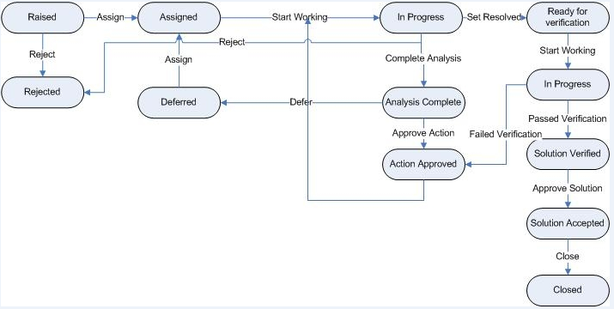

**Defect Workflow and States**

The following defect workflow states will be possible for a defect being logged:

**New** – When the QA team raises a new defect in RTC, the ‘State’ of the defect is set to ‘New’.

**Assigned** – From the QA team’s view, if the defect is ‘Valid’, the tester sets the ‘State’ to ‘Assigned’ by selecting the action ‘Assign’ and assign the defect to the developer. ‘Assigned To’ field must be selected with the developer to whom a particular defect is getting assigned. A ‘Closed’ defect can also be set to ‘Assigned’ state by selecting the ‘Reopen’ action whenever a defect needs to be reopened.

**In Progress** – Once the defect is assigned to the developer, the developer sets the ‘State’ to ‘In Progress’ by selecting the action ‘Start Working’. This means the developer has accepted the defect and is currently working on fixing the issue.

**Resolved** – Once the developer fixes the defect, sets the ‘State’ to ‘Resolved’ by selecting the action ‘Resolve’. Developer also selects the ‘Resolution’ as ‘Fixed’ as mentioned above when a defect gets fixed. Hence, when a valid defect is fixed, the developer must set the ‘State’ to ‘Resolved’ and ‘Resolution’ to ‘Fixed’. If there is no fix for the defect , then the developer sets the ‘State’ to ‘Resolved’ and ‘Resolution’ to one among the list mentioned above.

**Solution Verified** – When the ‘State’ and ‘Resolution’ of the defect is ‘Resolved’ and ‘Fixed’ respectively, it goes to the tester for retest. The tester starts retesting the defect and sets the ‘State’ to ‘Verified’ by selecting the action ‘Verify’ once the retest is done. If the retest passed, then the tester sets the ‘State’ to ‘Closed’ by selecting the action ‘Pass Retest’. If the retest failed, the tester sets the ‘State’ to ‘Assigned’ by selecting the action ‘Fail Retest’ and assign the defect back to the developer. The defect will be again worked upon by the developer.

**Deferred** – When the defect is in ‘In Progress’ state , it can be changed to ‘Deferred’ state by selecting the action ‘Defer’ if the development team won’t be able to provide the fix before the current release. These defects need to be discussed with the business/SME team to understand the areas of impact and then only upon their approval, these defects can be changed to ‘Deferred’ state.

**Rejected** – A defect can be set to ‘Rejected’ state by selecting the action ‘Reject’ in two ways. The tester can directly set the state to ‘Rejected’ if it’s an invalid/duplicate defect or the developer can change the state to ‘Rejected’ from the ‘Deferred’ state if a deferred defect is no longer required to be fixed.

**Closed** – A defect can be ‘Closed’ from the ‘Rejected’ state by selecting the action ‘Close’ and also from the ‘Verified’ state by selecting the action ‘Pass Retest’.

The above said change of state will be possible and built in within RTC to track the defect till closure.

**Defect Severity & Priority Definitions**

The tables below define generic Severity and Priority classifications criteria that will be followed while logging a defect.

|  |  |
| --- | --- |
| **Defect Severity Definition Table** | |
| **Severity** | **Classification Criteria** |
| 1 | Critical functional, business or operational process cannot be performed and / or has failed - no realistic or acceptable workaround exists. The entire solution is unacceptable and Implementation cannot proceed until resolution is provided - majority of users would be impacted.  Examples include, but are not limited to:   * Legal or Regulatory non-compliance * Incorrect customer facing correspondence * Corruption or loss of system / customer data * Incorrect financial transactions or recording * Projected volumes and throughput will not be supported * Etihad exposed to threat of reputational damage * Security threat or violation * Failure of software package deployment * System failure / downtime * Unable to access application |
| 2 | Malfunction of a solution component which would have a high impact on the functionality, operations or business usability of the system in Production (many users would be affected). An efficient manual workaround exists, which could realistically be used (i.e. without adverse cost or operational impact to Etihad).  Examples include, but are not limited to:   * Potential for incorrect or incomplete calculations / data * Maximum projected volumes and throughput will not be supported * Incorrect Management Information * Field validation failure * Reduced system privileges due to incorrect security profile definition * Inability to load infrequent inbound file - minor manual manipulation required * Fails a TCF principle |
| 3 | A defect with a medium Implementation impact - only a small number of users would be affected. An efficient manual workaround exists, which could realistically be used (i.e. without adverse costs or operational impact to Etihad). |
| 4 | A minor or cosmetic defect, which is non-customer facing and does not directly impact functionality or performance. |

|  |  |
| --- | --- |
| **Defect Priority Definition Table** | |
| **Priority** | **Classification Criteria** |
| 1 | All testing cannot be performed without the defect being resolved (=>30% of Test Plan blocked) |
| 2 | Considerable impact to the testing schedule and timeframes without the defect being resolved (=>15% of Test Plan blocked) |
| 3 | Specific functionality cannot be tested or cannot complete testing without the defect being resolved (=>5% of Test Plan blocked) |
| 4 | Elements of testing cannot be completed without the defect being resolved or a work-around being agreed (<5% of Test Plan blocked) |

**Defect Turnaround to be followed based on Defect Severity**

|  |  |  |
| --- | --- | --- |
| **Defect Priority Definition Table** | | |
| **Severity** | **Turnaround Time** | **Comments** |
| 1 |  |  |
| 2 |  |  |
| 3 |  |  |
| 4 |  |  |

**Defect Triaging/Review Meeting**

* For all the new defects that will be raised in RTC, defect triage meeting will be conducted between the development team and the Test team and all the clarifications/issues will be discussed during the meeting in order to fix the defect.
* SME/Business team will also be invited for the defect triage meetings if required to get any clarifications/inputs on any defects. For e.g.: when there will be a dispute between the development and Test teams for a defect, business team will be consulted before taking any final decision/before accepting or rejecting the defect.
* At any stage, a defect shall be assigned to the SME/Business team to get their inputs or for any clarifications. SME/Business team will update the inputs from their end and will assign the defect back to developer/tester or any other required person for further action.
* If a defect seems to be a ‘Change Request’, then it will be assigned to the ‘Change Control Board’ to get the approval and then it will be ‘Closed’ in RTC (mentioning the CR reference #) once the ‘Change Request’ is raised in the CR system/application.
* Regular defect triage meetings or review meetings will be conducted to track the status of all the existing defects and to discuss the new defects in order to get all the defects to closure.

**Assigning Defect to Vendor Supplier**

There are many ways in which a tester will be able to assign a defect to a Developer. In case where developer will have access to the RTC tool, RTC shall be mandatorily used for defect logging and tracking

Challenge may arises when a defect will need to be assigned to an external Vendor/Developer for remediation. In such instance the recipient of the defect from Etihad project team, would log a ticket with their helpdesk, enabling them to track the defect internally. However MTS would ensure that same defect is be created in RTC for internal Etihad Tracking.

One such example is Sabre. The following process will be adhered to log a Sabre Ticket

SABRE

• Defect will be first raised in RTC

• Defect will be raised with Sabre by Etihad Project team- OPTION 1: Via the community portal using the eService link at https://community.sabre.com. This is Sabre’s preferred means of raising Customer Validation Testing (CVT) defects. RTC reference will also be supplied in the Sabre Ticket.

• Defect will be raised with Sabre y Etihad Project team- OPTION 2: For urgent items (or to follow up on a CERT defect already open), IBM will call the numbers provided below. RTC reference will be required to be supplied to Sabre during the call.

• In all cases, the Sabre Siebel reference will have to be added to the RTC defect

Raising an urgent call / following up an existing call:

* UAE 2-518-6642
* UAE 800-035-702-569

COMARCH

* Defect will be raised in JIRA (Comarch Managed Tool) for all GLC related Testing where the development responsibilities lies with Comarch team.
* Defects related to integration, Web Interface Testing will continue to be raised in RTC for tracking and management.

**Defect Validation Process**

The individual test team leads/managers will need to ensure the following for their teams:

* All the defects logged in RTC by their teams will be logged with valid data, detailed description (steps) to understand the defect better.
* Proper attachments/screen shots will have to be uploaded to replicate the issue mentioned in the defect which will be easy for the developers to replicate the same issue in their environment.
* Defects will have to be assigned to the correct person for resolution.
* Test Team will be following up with the developer and ensure that the SLA’s for defect turnaround agreed being adhered
* Once the fix will be given, test team will make sure that the retest happens at the right time and returned back when the defect will fail retest.
* Test Team will ensure that the fixed defects are retested and closed in RTC on time.
* In addition to the above, the defect manager will also validate if the defects have been assigned to proper person, raised with valid status etc., in RTC and will work with the respective teams to get the data corrected for any discrepancies.

**Defect Reporting**

Defect Manager will be sending out a daily defect status report/metrics to all the teams and so that they can go through the defect statistics for their domains/areas on a daily basis and follow up with the developer/external vendor to get the defects fixed within the SLA’s. For an example, following is the defect extract from RTC of Airline operation area and the same is been extracted in a macro report to share with all stakeholders.

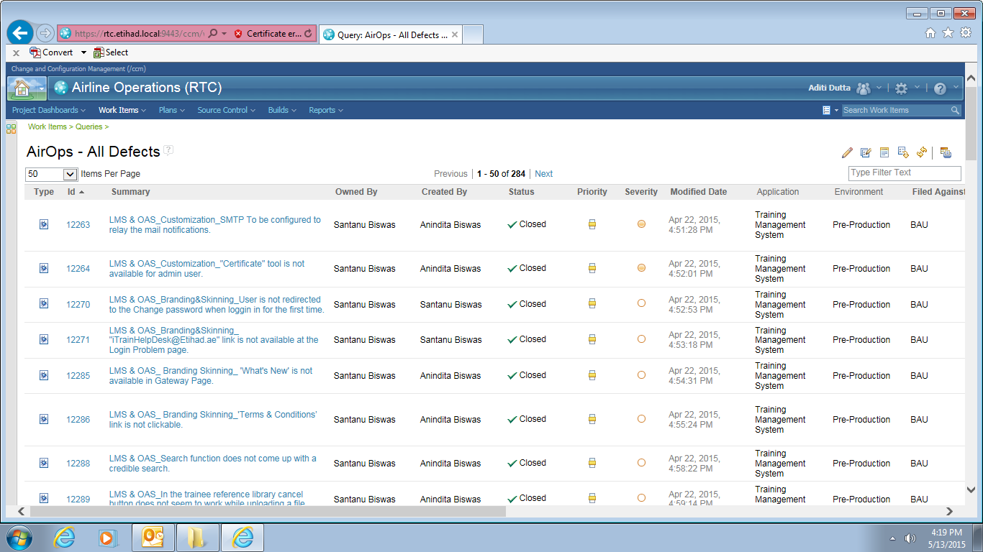

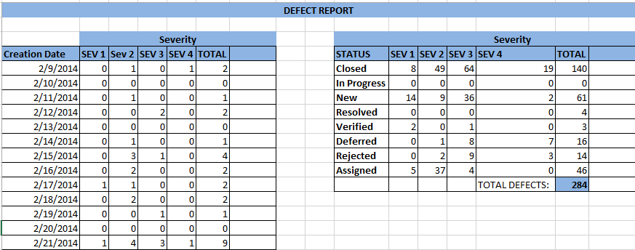

**Defect Logging In RTC**

Step by Step procedure for logging defects in RTC

Note: Features that will be enabled/disabled for the users in RTC is role based and hence as per the role given to the user, he/she will be able to perform the actions that are applicable for the assigned role.

Step 1 – Login to RTC using the URL -> <https://rtc.etihad.local:9443/ccm>

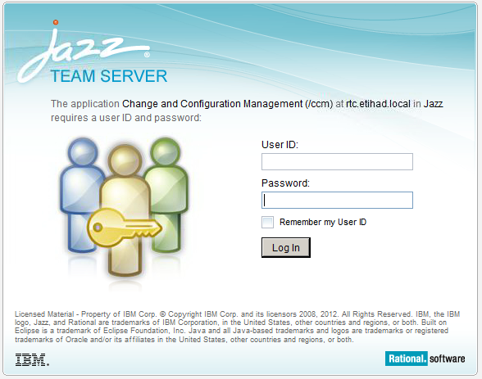

Provide your User ID and Password and Click on ‘Log In’

Step 2 – Select the project to which you are allocated as shown below and click on it.

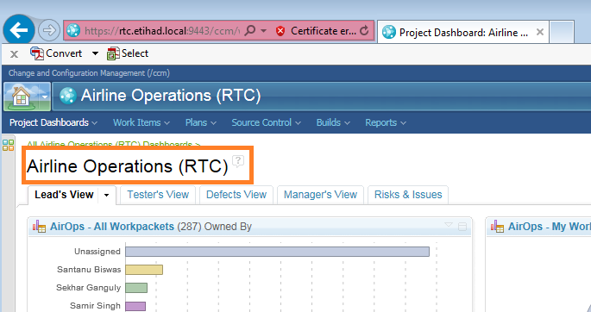

Step 3 - In RTC, all the tasks/issues/risks/defects etc. are categorized as ‘Work Items’ and hence the defects need to be raised under the ‘Work Items’.

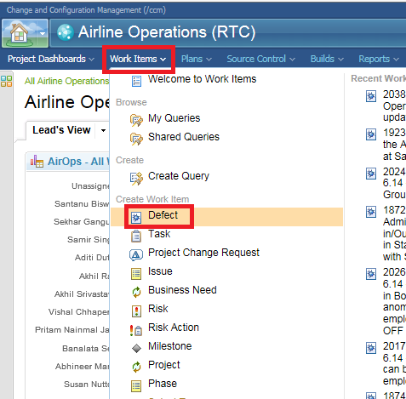

Step 4 – Click on ‘Defect’ as shown in the above picture to raise a new defect under the selected project.

‘New Defect’ page is shown as below

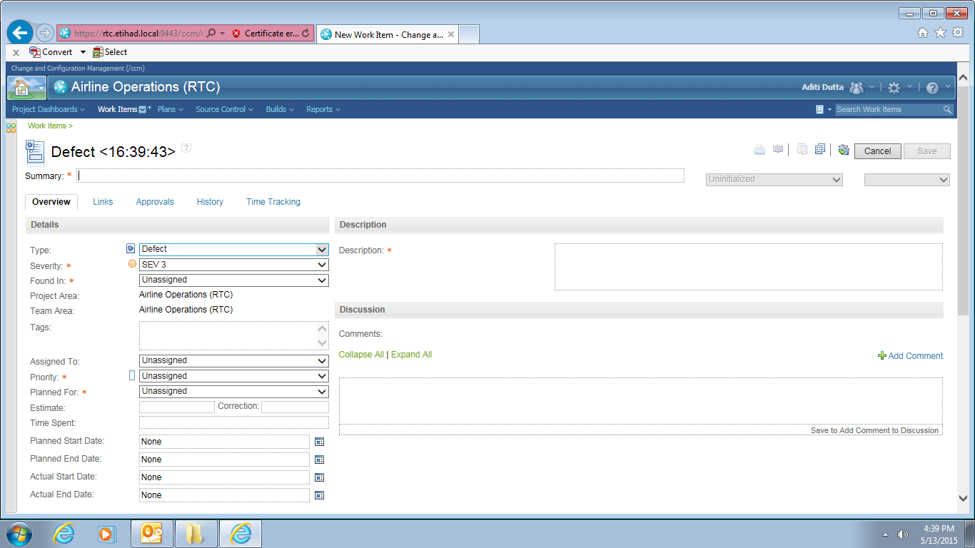

Step 5 Update all the details required for the defect and click on ‘Save’. Once Saved, the defect ‘State’ will be changed to ‘New’ and the user has to follow the defect workflow mentioned in Section 3 to start tracking the defects and bring it to closure.

**Defect Reports**

Note: The report illustrated below is only a sample. Users are requested to create their own query as per their requirement and run the report. In addition to the queries, user is also having ‘Reports’ menu in RTC which can be selected to use the shared/default reports or the user can also create his own report as per the project requirement under ‘Reports’ section.

Step 1 – To create the defect reports, click on ‘Create Query’ under the ‘Work Items’ as shown below

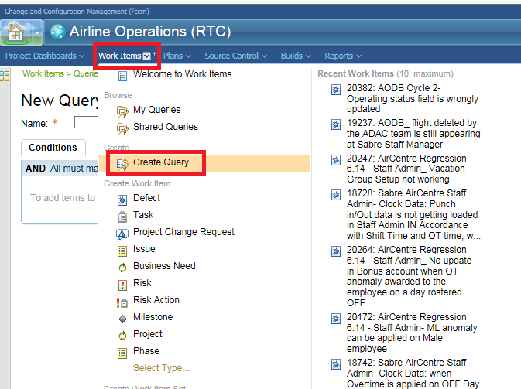

Step 2 – New Query creation page appears and shown as below:

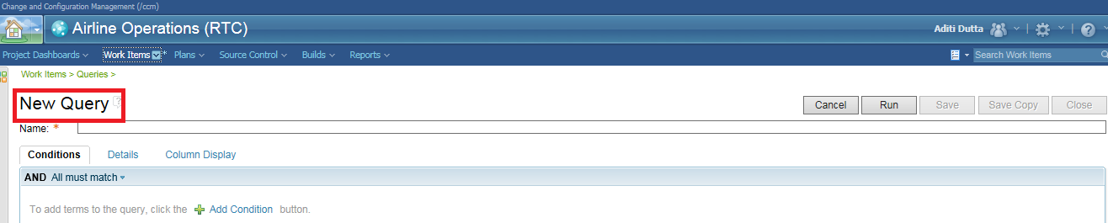

Enter the name for the query and click on ‘Add Condition’ as shown below

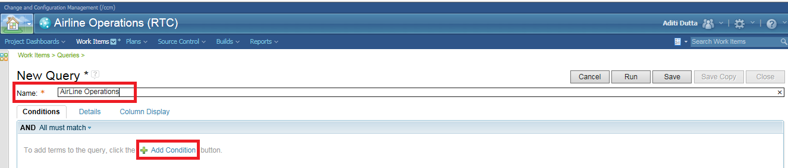

Step 3 – Search for ‘type’ under the ‘Add Condition’ and select ‘Type’ as shown below

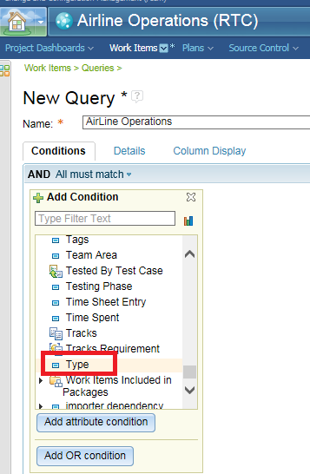

Step 4 – Double click on ‘Type’ shown in the above picture.

List of work item ‘Type’ will be displayed as shown below:

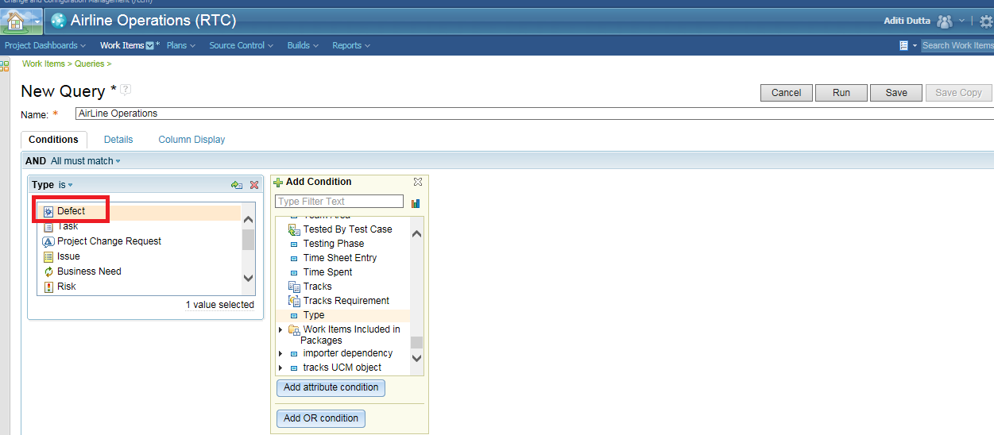

Select ‘Type’ as ‘Defect’ and click on ‘Save’ button

Step 5 – Once the query has been saved, Click on ‘Run’ button as shown below:

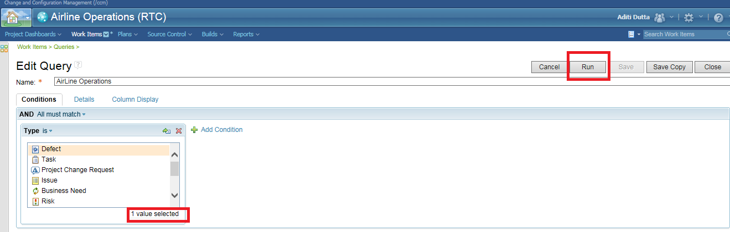

List of work items matching the type ‘Defect’ will be filtered and shown as below:



**Test Completion**

Test Completion Report (TCR) will be published as a mandatory artefact on completion of any test phase (SIT, Performance Test etc). Test Completion Report will act as a Test Signoff and a go ahead for promoting code to the next environment as a part to Etihad Route to live process.

The primary criteria for publishing a TCR will be execution completion of all planned test cases with no no open Sev 1 or 2 defects in the system. A problem record will be created in the Etihad Manage Engine and documented in the Test Completion Report for every open Sev 3 and Sev 4 defects.

Test Completion report will be reviewed and signed off by project stakeholders and will serve as a reference document in the Etihad Change Approval Board (CAB).

**Change Management Procedures**

**HE5: Handle Change Request**

The purpose of this procedure is to resolve a change request. This procedure is performed when a change to an aspect of the project that is under change control is requested. The request may come from the sponsor, the delivery organization, or a supplier. It may deal with a single major change or a number of small changes. It may address the schedule, resources, solution, or any aspect of the project. Handling the change request includes deciding whether it should be analysed further. If further analysis is launched, handling the change request involves revising base-lined elements and dependent documents (which may include the Agreement) along with communicating the change decisions to the team.

**Approvals**

The document approvals are attached in header section.

**Appendix A** **– Glossary of Testing Terms**

This glossary defines the testing terms used in this test strategy and the subsequent test documents. These definitions originate from many different industry standards and sources, such as the British Standards Institute (BSI), the Institute of Electrical and Electronics Engineers (IEEE), as well as from IBM.

| **Term** | **Definition** |
| --- | --- |
| **Acceptance Criteria** | The definition of the results expected from the test cases used for acceptance testing. The product must meet these criteria before implementation can be approved. |
| **Acceptance Testing** | (1) Formal testing conducted to determine whether or not a system satisfies its acceptance criteria and to enable the client to determine whether or not to accept the system.  (2) Formal testing conducted to enable a user, client, or other authorized entity to determine whether to accept a system or component. |
| **Acceptance Test Plan** | Describes the steps the client will use to verify that the constructed system meets the acceptance criteria. It defines the approach to be taken for acceptance testing activities. The plan identifies the items to be tested, the test objectives, the acceptance criteria, the testing to be performed, test schedules, entry/exit criteria, staff requirements, reporting requirements, evaluation criteria, and any risks requiring contingency planning. |
| **Ad-hoc Testing** | A loosely structured testing approach that allows test developers to be creative in their test selection and execution. Ad-hoc testing is targeted at known or suspected problem areas. |
| **Audit and Controls Testing** | A functional type of test that verifies the adequacy and effectiveness of controls and completeness of data processing results. |
| **Auditability** | A test focus area defined as the ability to provide supporting evidence to trace processing of data. |
| **Backup and Recovery Testing** | A structural type of test that verifies the capability of the application to be restarted after a failure. |
| **Black Box Testing** | Evaluation techniques that are executed without knowledge of the program’s implementation. The tests are based on an analysis of the specification of the component without reference to its internal workings. |
| **Bottom-up Testing** | Approach to integration testing where the lowest level components are tested first then used to facilitate the testing of higher level components. This process is repeated until the component at the top of the hierarchy is tested. See "Top-down." |
| **Boundary Value Analysis** | A test case selection technique that selects test data that lie along "boundaries" or extremes of input and output possibilities. Boundary Value Analysis can apply to parameters, classes, data structures, variables, loops, etc. |
| **Branch Testing** | A white box testing technique that requires each branch or decision point to be taken once. |
| **Build** | (1) An operational version of a system or component that incorporates a specified subset of the capabilities that the final product will provide. Builds are defined whenever the complete system cannot be developed and delivered in a single increment.  (2) A collection of programs within a system that are functionally independent. A build can be tested as a unit and can be installed independent of the rest of the system. |
| **Business Function** | A set of related activities that comprise a stand-alone unit of business. It may be defined as a process that results in the achievement of a business objective. It is characterized by well-defined start and finish activities and a workflow or pattern. |
| **Capability Maturity Model (CMM)** | A model of the stages through which software organizations progress as they define, implement, evolve, and improve their software process. This model provides a guide for selecting process improvement strategies by determining current process capabilities and identifying the issues most critical to software quality and process improvement. This concept was developed by the Software Engineering Institute (SEI) at Carnegie Mellon University. |
| **Causal Analysis** | The evaluation of the cause of major errors, to determine actions that will prevent reoccurrence of similar errors. |
| **Change Control** | The process, by which a change is proposed, evaluated, approved or rejected, scheduled, and tracked. |
| **Change**  **Management** | A process methodology to identify the configuration of a release and to manage all changes through change control, data recording, and updating of baselines. |
| **Change Request** | A documented proposal for a change of one or more work items or work item parts. |
| **Condition Testing** | A white box test method that requires all decision conditions be executed once for true and once for false. |
| **Configuration Management** | (1) The process of identifying and defining the configuration items in a system, controlling the release and change of these items throughout the system life cycle, recording and reporting the status of configuration items and change requests, and verifying the completeness and correctness of configuration items.  (2) A discipline applying technical and administrative direction and surveillance to (a) identify and document the functional and physical characteristics of a configuration items, (b) control changes to those characteristics, and (c) record and report change processing and implementation status. |
| **Conversion testing** | A functional type of test that verifies the compatibility of converted programs, data and procedures with the “old” ones that are being converted or replaced. |
| **Coverage** | The extent to which test data tests a program’s functions, parameters, inputs, paths, branches, statements, conditions, modules or data flow paths. |
| **Coverage Matrix** | Documentation procedure to indicate the testing coverage of test cases compared to possible elements of a program environment (i.e., inputs, outputs, parameters, paths, cause-effects, equivalence partitioning, etc.) |
| **Continuity of Processing** | A test focus area defined as the ability to continue processing if problems occur. Included is the ability to backup and recover after a failure. |
| **Correctness** | A test focus area defined as the ability to process data according to prescribed rules. Controls over transactions and data field edits provide an assurance on accuracy and completeness of data. |
| **Data flow Testing** | Testing in which test cases are designed based on variable usage within the code. |
| **Debugging** | The process of locating, analysing, and correcting suspected faults. Compare with testing. |
| **Decision Coverage** | Percentage of decision outcomes that have been exercised through (white box) testing. |
| **Defect** | A variance from expectations. See also Fault. |
| **Defect Management** | A set of processes to manage the tracking and fixing of defects found during testing and to perform causal analysis. |
| **Documentation and Procedures Testing** | A functional type of test that verifies that the interface between the system and the people works and is usable. It also verifies that the instruction guides are helpful and accurate. |
| **Design Review** | (1) A formal meeting at which the preliminary or detailed design of a system is presented to the user, customer or other interested parties for comment and approval.  (2) The formal review of an existing or proposed design for the purpose of detection and remedy of design deficiencies that could affect fitness-for-use and environmental aspects of the product, process or service, and/or for identification of potential improvements of performance, safety and economic aspects. |
| **Desk Check** | Testing of software by the manual simulation of its execution. It is one of the static testing techniques. |
| **Detailed Test Plan** | The detailed plan for a specific level of dynamic testing. It defines what is to be tested and how it is to be tested. The plan typically identifies the items to be tested, the test objectives, the testing to be performed, test schedules, personnel requirements, reporting requirements, evaluation criteria, and any risks requiring contingency planning. It also includes the testing tools and techniques, test environment set up, entry and exit criteria, and administrative procedures and controls. |
| **Driver** | A program that exercises a system or system component by simulating the activity of a higher level component. |
| **Dynamic Testing** | Testing that is carried out by executing the code. Dynamic testing is a process of validation by exercising a work product and observing the behaviour of its logic and its response to inputs. |
| **Entry Criteria** | A checklist of activities or work items that must be complete or exist, respectively, before the start of a given task within an activity or sub-activity. |
| **Environment** | See Test Environment. |
| **Equivalence Partitioning** | Portion of the component’s input or output domains for which the component’s behaviour is assumed to be the same from the component’s specification. |
| **Error** | (1) A discrepancy between a computed, observed or measured value or condition and the true specified or theoretically correct value or condition.  (2) A human action that results in software containing a fault. This includes omissions or misinterpretations, etc. See Variance. |
| **Error Guessing** | A test case selection process that identifies test cases based on the knowledge and ability of the individual to anticipate probable errors. |
| **Error Handling Testing** | A functional type of test that verifies the system function for detecting and responding to exception conditions. Completeness of error handling determines the usability of a system and ensures that incorrect transactions are properly handled. |
| **Execution Procedure** | A sequence of manual or automated steps required to carry out part or all of a test design or execute a set of test cases. |
| **Exit Criteria** | (1) Actions that must happen before an activity is considered complete.  (2) A checklist of activities or work items that must be complete or exist, respectively, prior to the end of a given process stage, activity, or sub-activity. |
| **Expected Results** | Predicted output data and file conditions associated with a particular test case. Expected results, if achieved, will indicate whether the test was successful or not. Generated and documented with the test case prior to execution of the test. |
| **Fault** | (1) An accidental condition that causes a functional unit to fail to perform its required functions.  (2) A manifestation of an error in software. A fault if encountered may cause a failure. Synonymous with bug. |
| **Full Lifecycle Testing** | The process of verifying the consistency, completeness, and correctness of software and related work products (such as documents and processes) at each stage of the development life cycle. |
| **Function** | (1) A specific purpose of an entity or its characteristic action.  (2) A set of related control statements that perform a related operation. Functions are sub-units of modules. |
| **Function Testing** | A functional type of test, which verifies that each business function, operates according to the detailed requirements, the external and internal design specifications. |
| **Functional Testing** | Selecting and executing test cases based on specified function requirements without knowledge or regard of the program structure. Also known as black box testing. See "Black Box Testing." |
| **Functional Test Types** | Those kinds of tests used to assure that the system meets the business requirements, including business functions, interfaces, usability, audit & controls, and error handling etc. See also Structural Test Types. |
| **Implementation** | (1) A realization of an abstraction in more concrete terms; in particular, in terms of hardware, software, or both.  (2) The process by which software release is installed in production and made available to end users. |
| **Inspection** | (1) A group review quality improvement process for written material, consisting of two aspects: product (document itself) improvement and process improvement (of both document production and inspection).  (2) A formal evaluation technique in which software requirements, design, or code are examined in detail by a person or group other than the author to detect faults, violations of development standards, and other problems. Contrast with walk-through. |
| **Installation Testing** | A functional type of test which verifies that the hardware, software and applications can be easily installed and run in the target environment. |
| **Integration Testing** | A level of dynamic testing which verifies the proper execution of application components and does not require that the application under test interface with other applications. |
| **Interface / Inter-system Testing** | A functional type of test which verifies that the interconnection between applications and systems functions correctly. |
| **JAD** | An acronym for Joint Application Design. Formal session(s) involving clients and developers used to develop and document consensus on work products, such as client requirements, design specifications, etc. |
| **Level of Testing** | Refers to the progression of software testing through static and dynamic testing.  Examples of static testing levels are Project Objectives Review, Requirements Walkthrough, Design (External and Internal) Review, and Code Inspection.  Examples of dynamic testing levels are: Unit Testing, Integration Testing, System Testing, Acceptance Testing, Systems Integration Testing and Operability Testing.  Also known as a test level. |
| **Lifecycle** | The software development process stages. Requirements, Design, Construction (Code/Program, Test), and Implementation. |
| **Logical Path** | A path that begins at an entry or decision statement and ends at a decision statement or exit. |
| **Maintainability** | A test focus area defined as the ability to locate and fix an error in the system. Can also be the ability to make dynamic changes to the system environment without making system changes. |
| **Master Test Plan** | A plan that addresses testing from a high-level system viewpoint. It ties together all levels of testing (unit test, integration test, system test, acceptance test, systems integration, and operability). It includes test objectives, test team organization and responsibilities, high-level schedule, test scope, test focus, test levels and types, test facility requirements, and test management procedures and controls. |
| **Operability** | A test focus area defined as the effort required (of support personnel) to learn and operate a manual or automated system. Contrast with Usability. |
| **Operability Testing** | A level of dynamic testing in which the operations of the system are validated in the real or closely simulated production environment. This includes verification of production JCL, installation procedures and operations procedures. Operability Testing considers such factors as performance, resource consumption, adherence to standards, etc. Operability Testing is normally performed by Operations to assess the readiness of the system for implementation in the production environment. |
| **Operational Testing** | A structural type of test that verifies the ability of the application to operate at an acceptable level of service in the production-like environment. |
| **Parallel Testing** | A functional type of test, which verifies that the same input on “old” and “new” systems, produces the same results. It is more of an implementation that a testing strategy. |
| **Path Testing** | A white box testing technique that requires all code or logic paths to be executed once. Complete path testing is usually impractical and often uneconomical. |
| **Performance** | A test focus area defined as the ability of the system to perform certain functions within a prescribed time. |
| **Performance Testing** | A structural type of test which verifies that the application meets the expected level of performance in a production-like environment. |
| **Portability** | A test focus area defined as ability for a system to operate in multiple operating environments. |
| **Problem** | (1) A call or report from a user. The call or report may or may not be defect oriented.  (2) A software or process deficiency found during development.  (3) The inhibitors and other factors that hinder an organization’s ability to achieve its goals and critical success factors.  (4) An issue that a project manager has the authority to resolve without escalation. Compare to ‘defect’ or ‘error’. |
| **Quality Plan** | A document which describes the organization, activities, and project factors that have been put in place to achieve the target level of quality for all work products in the application domain. It defines the approach to be taken when planning and tracking the quality of the application development work products to ensure conformance to specified requirements and to ensure the client’s expectations are met. A |
| **Regression Testing** | A functional type of test, which verifies that changes to one part of the system have not caused unintended adverse effects to other parts. |
| **Reliability** | A test focus area defined as the extent to which the system will provide the intended function without failing. |
| **Requirement** | (1) A condition or capability needed by the user to solve a problem or achieve an objective.  (2) A condition or capability that must be met or possessed by a system or system component to satisfy a contract, standard, specification, or other formally imposed document. The set of all requirements forms the basis for subsequent development of the system or system component. |
| **Review** | A process or meeting during which a work product, or set of work products, is presented to project personnel, managers, users or other interested parties for comment or approval. |
| **Root Cause Analysis** | See Causal Analysis. |
| **Scaffolding** | Temporary programs may be needed to create or receive data from the specific program under test. This approach is called scaffolding. |
| **Security** | A test focus area defined as the assurance that the system/data resources will be protected against accidental and/or intentional modification or misuse. |
| **Security Testing** | A structural type of test which verifies that the application provides an adequate level of protection for confidential information and data belonging to other systems. |
| **Software Quality** | (1) The totality of features and characteristics of a software product that bear on its ability to satisfy given needs; for example, conform to specifications. (2) The degree to which software possesses a desired combination of attributes.  (3)The degree to which a customer or user perceives that software meets his or her composite expectations.  (4)The composite characteristics of software that determine the degree to which the software in use will meet the expectations of the customer. |
| **Software Reliability** | (1) The probability that software will not cause the failure of a system for a specified time under specified conditions. The probability is a function of the inputs to and use of the system as well as a function of the existence of faults in the software. The inputs to the system determine whether existing faults, if any, are encountered.  (2) The ability of a program to perform a required function under stated conditions for a stated period of time. |
| **Statement Testing** | A white box testing technique that requires all code or logic statements to be executed at least once. |
| **Static Testing** | (1) The detailed examination of a work product's characteristics to an expected set of attributes, experiences and standards. The product under scrutiny is static and not exercised and therefore its behaviour to changing inputs and environments cannot be assessed.  (2) The process of evaluating a program without executing the program. See also desk checking, inspection, walk-through. |
| **Stress / Volume Testing** | A structural type of test that verifies that the application has acceptable performance characteristics under peak load conditions. |
| **Structural Function** | Structural functions describe the technical attributes of a system. |
| **Structural Test Types** | Those kinds of tests that may be used to assure that the system is technically sound. |
| **Stub** | (1) A dummy program element or module used during the development and testing of a higher-level element or module.  (2) A program statement substituting for the body of a program unit and indicating that the unit is or will be defined elsewhere.  The inverse of Scaffolding. |
| **Sub-system** | (1) A group of assemblies or components or both combined to perform a single function.  (2) A group of functionally related components that are defined as elements of a system but not separately packaged. |
| **System** | A collection of components organized to accomplish a specific function or set of functions. |
| **Systems Integration Testing** | A dynamic level of testing which ensures that the systems integration activities appropriately address the integration of application subsystems, integration of applications with the infrastructure, and impact of change on the current live environment. |
| **System Testing** | A dynamic level of testing in which all the components that comprise a system are tested to verify that the system functions together as a whole. |
| **Test Bed** | (1) A test environment containing the hardware, instrumentation tools, simulators, and other support software necessary for testing a system or system component.  (2) A set of test files, (including databases and reference files), in a known state, used with input test data to test one or more test conditions, measuring against expected results. |
| **Test Case** | (1) A set of test inputs, execution conditions, and expected results developed for a particular objective, such as to exercise a particular program path or to verify compliance with a specific requirement.  (2) The detailed objectives, data, procedures and expected results to conduct a test or part of a test. |
| **Test Condition** | A functional or structural attribute of an application, system, network, or component thereof to be tested. |
| **Test Conditions Matrix** | A worksheet used to formulate the test conditions that, if met, will produce the expected result. It is a tool used to assist in the design of test cases. |
| **Test Conditions Coverage Matrix** | A worksheet that is used for planning and for illustrating that all test conditions are covered by one or more test cases. Each test set has a Test Conditions Coverage Matrix. Rows are used to list the test conditions and columns are used to list all test cases in the test set. |
| **Test Coverage Matrix** | A worksheet used to plan and cross check to ensure all requirements and functions are covered adequately by test cases. |
| **Test Data** | The input data and file conditions associated with a specific test case. |
| **Test Environment** | The external conditions or factors that can directly or indirectly influence the execution and results of a test. This includes the physical as well as the operational environments. Examples of what is included in a test environment are: I/O and storage devices, data files, programs, JCL, communication lines, access control and security, databases, reference tables and files (version controlled), etc. |
| **Test Focus Areas** | Those attributes of an application that must be tested in order to assure that the business and structural requirements are satisfied. |
| **Test Level** | See Level of Testing. |
| **Test Log** | A chronological record of all relevant details of a testing activity. |
| **Test Matrices** | A collection of tables and matrices used to relate functions to be tested with the test cases that do so. Worksheets used to assist in the design and verification of test cases. |
| **Test Objectives** | The tangible goals for assuring that the Test Focus areas previously selected as being relevant to a particular Business or Structural Function are being validated by the test. |
| **Test Plan** | A document prescribing the approach to be taken for intended testing activities. The plan typically identifies the items to be tested, the test objectives, the testing to be performed, test schedules, entry / exit criteria, personnel requirements, reporting requirements, evaluation criteria, and any risks requiring contingency planning. |
| **Test Procedure** | Detailed instructions for the setup, operation, and evaluation of results for a given test. A set of associated procedures is often combined to form a test procedures document. |
| **Test Report** | A document describing the conduct and results of the testing carried out for a system or system component. |
| **Test Run** | A dated, time-stamped execution of a set of test cases. |
| **Test Scenario** | A high-level description of how a given business or technical requirement will be tested, including the expected outcome; later decomposed into sets of test conditions, each in turn, containing test cases. |
| **Test Script** | A sequence of actions that executes a test case. Test scripts include detailed instructions for set up, execution, and evaluation of results for a given test case. |
| **Test Set** | A collection of test conditions. Test sets are created for purposes of test execution only. A test set is created such that its size is manageable to run and its grouping of test conditions facilitates testing. The grouping reflects the application build strategy. |
| **Test Sets Matrix** | A worksheet that relates the test conditions to the test set in which the condition is to be tested. Rows list the test conditions and columns list the test sets. A checkmark in a cell indicates the test set will be used for the corresponding test condition. |
| **Test Specification** | A set of documents that define and describe the actual test architecture, elements, approach, data and expected results. Test Specification uses the various functional and non-functional requirement documents along with the quality and test plans. It provides the complete set of test cases and all supporting detail to achieve the objectives documented in the detailed test plan. |
| **Test Strategy** | A high level description of major system-wide activities which collectively achieve the overall desired result as expressed by the testing objectives, given the constraints of time and money and the target level of quality. It outlines the approach to be used to ensure that the critical attributes of the system are tested adequately. |
| **Test Type** | See Type of Testing. |
| **Testability** | (1) The extent to which software facilitates both the establishment of test criteria and the evaluation of the software with respect to those criteria.  (2) The extent to which the definition of requirements facilitates analysis of the requirements to establish test criteria. |
| **Testing** | The process of exercising or evaluating a program, product, or system, by manual or automated means, to verify that it satisfies specified requirements, to identify differences between expected and actual results. |
| **Test ware** | The elements that are produced as part of the testing process. Test ware includes plans, designs, test cases, test logs, test reports, etc. |
| **Top-down** | Approach to integration testing where the component at the top of the component hierarchy is tested first, with lower level components being simulated by stubs. Tested components are then used to test lower level components. The process is repeated until the lowest level components have been tested. |
| **Transaction Flow Testing** | A functional type of test that verifies the proper and complete processing of a transaction from the time it enters the system to the time of its completion or exit from the system. |
| **Type of Testing** | Tests a functional or structural attribute of the system. E.g., Error Handling, Usability. (Also known as test type.) |
| **Unit Testing** | The first level of dynamic testing and is the verification of new or changed code in a module to determine whether all new or modified paths function correctly. |
| **Usability** | A test focus area defined as the end-user effort required to learn and use the system. Contrast with Operability. |
| **Usability Testing** | A functional type of test which verifies that the final product is user-friendly and easy to use. |
| **User Acceptance Testing** | See Acceptance Testing. |
| **Validation** | (1) The act of demonstrating that a work item is in compliance with the original requirement. For example, the code of a module would be validated against the input requirements it is intended to implement. Validation answers the question "Is the right system being built?”  (2) Confirmation by examination and provision of objective evidence that the particular requirements for a specific intended use have been fulfilled. See "Verification". |
| **Variance** | A mismatch between the actual and expected results occurring in testing. It may result from errors in the item being tested, incorrect expected results, invalid test data, etc. See "Error". |
| **Verification** | (1) The act of demonstrating that a work item is satisfactory by using its predecessor work item. For example, code is verified against module level design. Verification answers the question "Is the system being built right?”  (2) Confirmation by examination and provision of objective evidence that specified requirements have been fulfilled. See "Validation." |
| **Walkthrough** | A review technique characterized by the author of the object under review guiding the progression of the review. Observations made in the review are documented and addressed. Less formal evaluation technique than an inspection. |
| **White Box Testing** | Evaluation techniques that are executed with the knowledge of the implementation of the program. The objective of white box testing is to test the program's statements, code paths, conditions, or data flow paths. |
| **Work Item** | A software development lifecycle work product. |